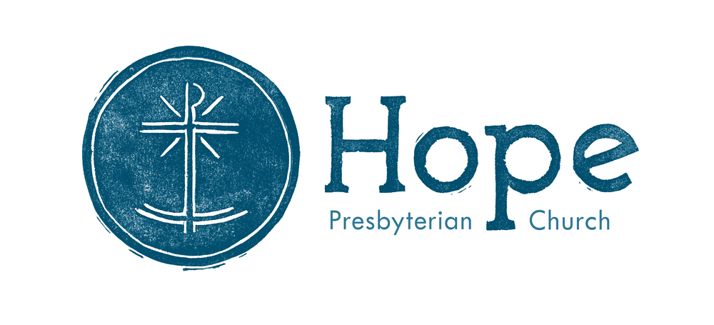

Hope Presbyterian Church
Accessible Worship Folder
June 23, 2024
www.hopechurchcolumbus.org
Pastor—Joe Haack—joe@hopechurchcolumbus.org
Youth Pastor—Wes Piehl—wes@hopechurchcolumbus.org
Deacons—deacons@hopechurchcolumbus.org
Operations Manager—Nichole Redinger—operations@hopechurchcolumbus.org

PREPARATION FOR WORSHIP

Reflection before the Service
Fill our worship with grace, Lord Jesus Christ, that every thought, word, and deed may be acceptable to you, our Rock and our Redeemer. Amen.

CALL TO WORSHIP
From Revelation 15:3-4, NIV

LEADER
Hear what the Spirit is saying to the church.

ALL
Great and marvelous are your deeds, Lord God Almighty. Just and true are your ways, King of the nations. Who will not fear you, Lord, and bring glory to your name? For you alone are holy. All nations will come and worship before you.

DOXOLOGY
Praise God from whom all blessings flow;
Praise him all creatures here below;
Praise him above, ye heavenly host;
Praise Father, Son, and Holy Ghost.
Amen.

PRAYER OF INVOCATION

LEADER
God of light and truth,
you are beyond our grasp or conceiving. Before the brightness of your presence
the angels veil their faces.

ALL
With lowly reverence and adoring love we acclaim your glory and sing your praise,
for you have shown us your truth and love in Jesus Christ, our Savior. Amen.

HYMNS

Be Thou My Vision

Verse:
Be Thou my vision, O Lord of my heart;
Naught be all else to me, save that Thou art
Thou my best thought, by day or by night,
Waking or sleeping, Thy presence my light.

Verse:
Be Thou my wisdom, and Thou my true Word;
I ever with Thee and Thou with me, Lord;
Thou my great Father, and I Thy true son;
Thou in me dwelling, and I with Thee one.

Verse:
Riches I heed not, nor man’s empty praise,
Thou mine inheritance, now and always:
Thou and Thou only, first in my heart,
High king of heaven, my treasure Thou art.

Verse:
High king of heaven, my victory won,
May I reach heaven’s joys,
O bright heaven’s sun!
Heart of my own heart, whatever befall,
Still be my vision, O ruler of all.

Jesus, Cast a Look On Me

Verse:
Jesus, cast a look on me;
Give me sweet simplicity;
Make me poor, and keep me low,
Seeking only Thee to know.

Verse:
Weaned from all my lordly self,
Weaned from all the miser’s pelf,
Weaned from all the scorner’s ways,
Weaned from all the lust of praise.

Verse:
All that feeds my busy pride,
Cast it evermore aside;
Bid my will to Thine submit,
Lay me humbly at Thy feet.

Verse:
Make me like a little child,
Of my strength and wisdom spoiled;
Seeing only in Thy light,
Walking only in Thy might;

Verse:
Leaning on Thy loving breast,
Where a weary soul may rest;
Feeling well the peace of God
Flowing from Thy precious blood.

Verse:
In this posture let me live,
And hosannas daily give;
In this temper let me die,
And hosannas ever cry.

CONFESSION OF SIN
From Psalm 130, NRSV

LEADER
Out of the depths I cry to you, O, Lord. Lord, hear my voice! Let your ears be attentive
to the voice of my supplications! If you, O Lord, should mark iniquities, Lord, who could stand? But there is forgiveness with you, so that you may be revered.

ALL
I wait for the LORD, my soul waits, and in his word I hope; my soul waits for the Lord
more than those who watch for the morning, more than those who watch for the morning. O, Israel, hope in the Lord! For with the Lord there is steadfast love, and with him is great power to redeem. It is he who will redeem Israel from all its iniquities.

HYMN

I Shall Not Want

Verse:
From the love of my own comfort
From the fear of having nothing
From a life of worldly passions
Deliver me O God

Verse:
From the need to be understood
From the need to be accepted
From the fear of being lonely
Deliver me O God
Deliver me O God

Chorus:
And I shall not want, I shall not want
when I taste Your goodness I shall not want
when I taste Your goodness I shall not want

Verse:
From the fear of serving others
From the fear of death or trial
From the fear of humility
Deliver me O God
Deliver me O God

Chorus:
And I shall not want, I shall not want
when I taste Your goodness I shall not want
And I shall not want, I shall not want
when I taste Your goodness I shall not want
when I taste Your goodness I shall not want
And I shall not want, I shall not want

Bridge:
Oh how I need You
Oh how I need You
Oh how I need You
Oh how I need You

GRACE ASSURANCE
From Psalm 103:8, 13-14, 17-18, NRSV

LEADER
The LORD is merciful and gracious, slow to anger and abounding in steadfast love. As a father has compassion for his children, so the LORD has compassion for those who fear him. For he knows how we were made; he remembers that we are dust. But the steadfast love of the LORD is from everlasting to everlasting on those who fear him,
and his righteousness to children’s children, to those who keep his covenant and remember to do his commandments.

HYMN

On Jordan's Stormy Banks (Promised Land)

Verse:
On Jordan's stormy banks I stand
And cast a wishful eye
To Canaan's fair and happy land
Where my possessions lie

Chorus:
I am bound
For the promised land
I am bound
For the promised land
O who will come
And go with me
I am bound
For the promised land

Verse:
All o'er those wide extended plains
Shines one eternal day
There God the Son forever reigns
And scatters night away

Chorus:
I am bound
For the promised land
I am bound
For the promised land
O who will come
And go with me
I am bound
For the promised land

Verse:
No chilling winds
Nor poisonous breath
Can reach that healthful shore
Sickness and sorrow
Pain and death
Are felt and feared no more

Verse:
When shall I reach
That happy place
And be forever blest
When shall I see
My Father's face
And in His bosom rest

TITHES & OFFERINGS

PASSING THE PEACE

SCRIPTURE READING

MESSAGE

Slide 1
A life of avoidance or spirit-filled purpose?

Slide 2
- The high stakes of rejecting Jesus.
- The removal of shame in receiving Jesus.
- The privilege of priesthood through Jesus.

Slide 3
- The high stakes of rejecting Jesus.

Slide 4
1 Peter 4-8: “As you come to him, a living stone rejected by men but in the sight of God chosen and precious, you yourselves like living stones are being built up as a spiritual house, to be a holy priesthood, to offer spiritual sacrifices acceptable to God through Jesus Christ. For it stands in Scripture: “Behold, I am laying in Zion a stone, a cornerstone chosen and precious, and whoever believes in him will not be put to shame.” So the honor is for you who believe, but for those who do not believe, “The stone that the builders rejected has become the cornerstone,” and “A stone of stumbling, and a rock of offense.”

Slide 5
- The removal of shame in receiving Jesus.

Slide 6
1 Peter 4-8: “As you come to him, a living stone rejected by men but in the sight of God chosen and precious, you yourselves like living stones are being built up as a spiritual house, to be a holy priesthood, to offer spiritual sacrifices acceptable to God through Jesus Christ. For it stands in Scripture: “Behold, I am laying in Zion a stone, a cornerstone chosen and precious, and whoever believes in him will not be put to shame.” So the honor is for you who believe, but for those who do not believe, “The stone that the builders rejected has become the cornerstone,” and “A stone of stumbling, and a rock of offense.”

Slide 7
- The privilege of priesthood through Jesus.

Slide 8
1 Peter 5: “... you yourselves like living stones are being built up as a spiritual house, to be a holy priesthood, to offer spiritual sacrifices acceptable to God through Jesus Christ.”

CONFESSION OF FAITH
Heidelberg Catechism #119

LEADER
What is the Lord's prayer?

ALL
Our Father in heaven, hallowed be your name, your kingdom come, your will be done on earth as it is in heaven. Give us today our daily bread. Forgive us our debts, as we also have forgiven our debtors. And lead us not into temptation, but deliver us from the evil one, for yours is the kingdom and the power and the glory forever. Amen.

THE LORD’S SUPPER

1 Corinthians 11:23-26
The Lord Jesus, on the night when he was betrayed took bread and when he had given thanks, he broke it and said, “This is my body which is broken for you. Do this in remembrance of me.” In the same way also he took the cup, after supper, saying, “This cup is the new covenant in my blood. Do this as often as you drink it, in remembrance of me."

HYMN

Restore Us Again

Verse
We longed for Egypt in the wilderness
A kingdom made of dust
Built an idol out of happiness
A paradise of rust

Pre-Chorus:
We lost all the meaning
Drowned out the feeling
Our hearts barely beating

Chorus:
Restore us again, God of our salvation
Revive us again in Your unfailing love
Restore us again, God of our salvation
Revive us again in Your unfailing love

Verse:
We have trusted in the meaningless
And chased a life of ease
Now we wander in the shadow lands
Where comfort is our king

Pre-Chorus:
We lost all the meaning
Drowned out the feeling
Our hearts barely beating
Restore us again, God of our salvation
Revive us again in Your unfailing love
Restore us again, God of our salvation
Revive us again in Your unfailing love

Bridge:
Holy Spirit bring us life once again
Holy Spirit lead our hearts back to You
Holy Spirit bring us life once again
Holy Spirit lead our hearts back to You

Chorus:
Restore us again, God of our salvation
Revive us again in Your unfailing love
Restore us again, God of our salvation
Revive us again in Your unfailing love

BENEDICTION
Go in peace, in the knowledge of God’s power. Go in confidence, in the knowledge of God’s strength. Go in joy, in the knowledge of God’s love.

HOPE HAPPENINGS

MEAL VOLUNTEERS NEEDED
Please consider signing up to provide a meal for our SHAN study group. Access the sign-up sheet with the Hope QR code.

Digital Connect Card
We’re glad you’re here! Let’s stay connected; please fill out the form at the following link: https://hopechurchcolumbus.churchcenter.com/people/forms/281549.

