# A wholly lamb linocut with a Hope Church Columbus logo featuring a stamped chi-rho cross superimposed on an anchor

# Hope Presbyterian Church Accessible Worship Folder and Slide Deck Transcription

**March 15, 2025**

[www.hopechurchcolumbus.org](http://www.hopechurchcolumbus.org)

Pastor—Joe Haack—[joe@hopechurchcolumbus.org](mailto:joe@hopechurchcolumbus.org)

Youth Pastor—Wes Piehl—[wes@hopechurchcolumbus.org](mailto:wes@hopechurchcolumbus.org)

Deacons—[deacons@hopechurchcolumbus.org](mailto:deacons@hopechurchcolumbus.org)

Operations Manager—Nichole Redinger—[operations@hopechurchcolumbus.org](mailto:operations@hopechurchcolumbus.org)

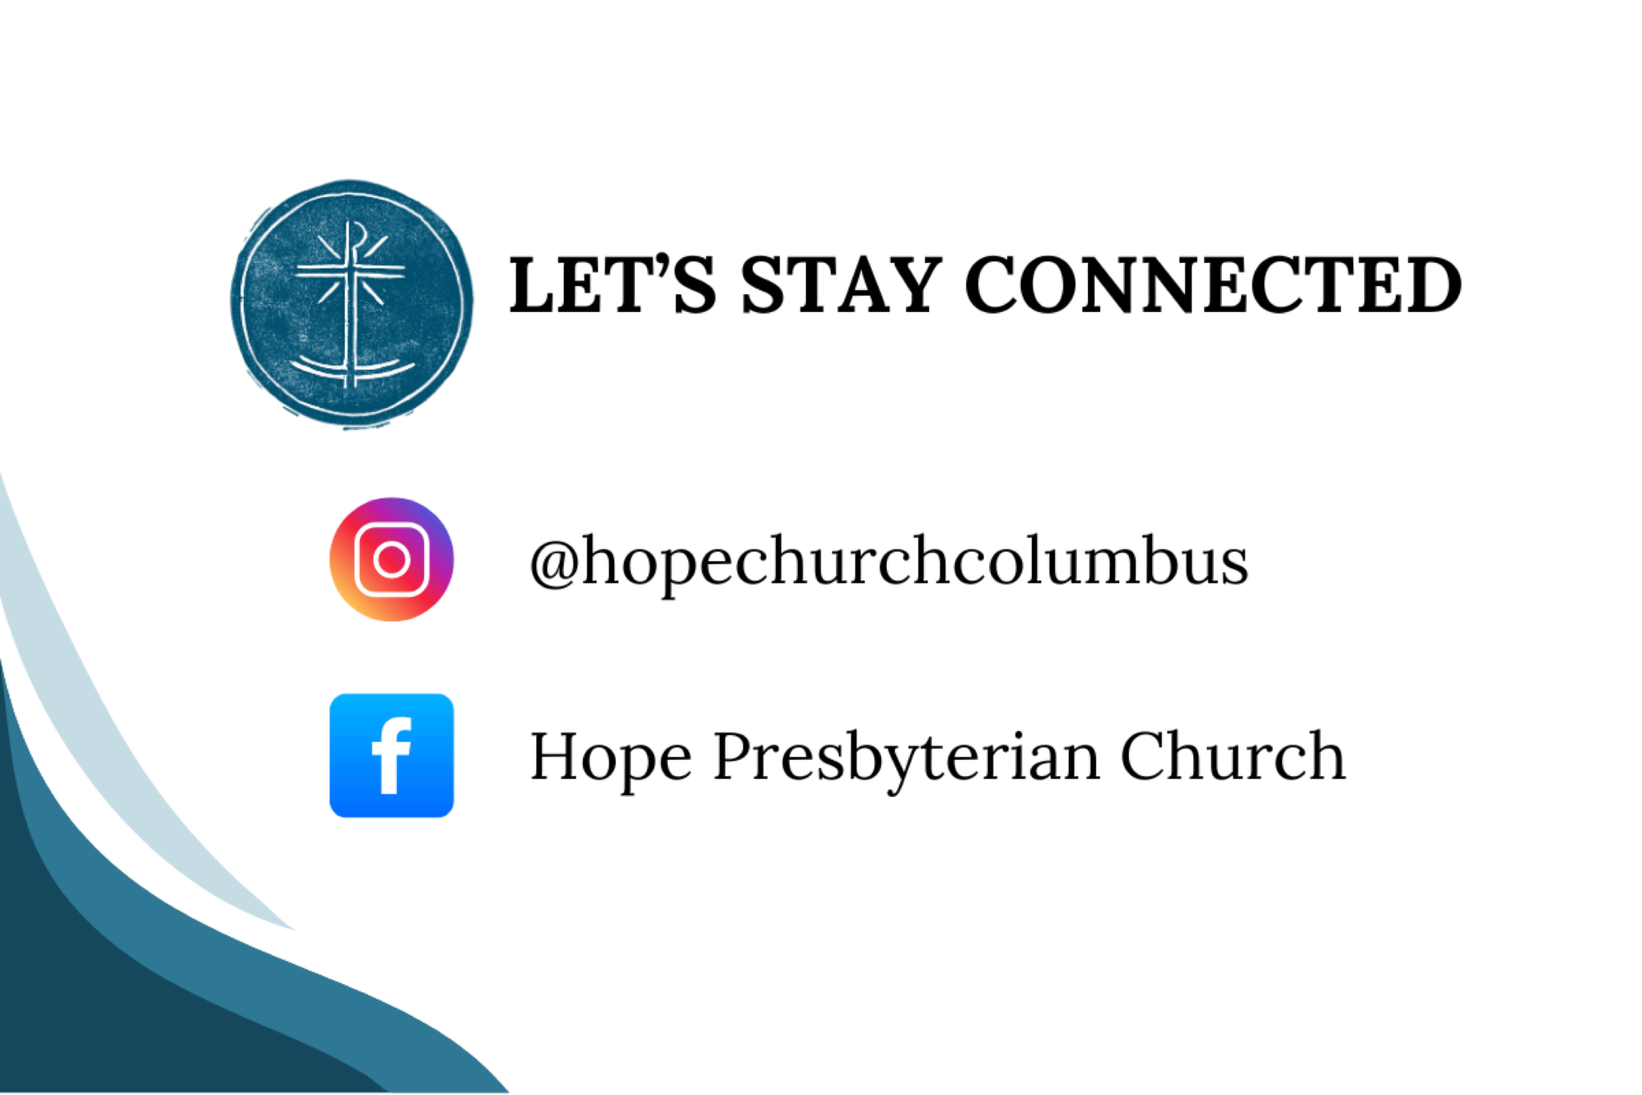

## PREPARATION FOR WORSHIP (Reflection before the Service)

Let us praise the Son first of all, venerating the blood that expiated our sins. He lost nothing of his divinity when he saved me, when like a good physician he stooped to my festering wounds. He was a mortal man, but he was also God. (Gregory of Nazianzus)

## CALL TO WORSHIP

(Psalm 51:15-17)

### Leader

O Lord, open my lips,

and my mouth will declare your praise.

You do not delight in sacrifice, or I would bring it;

you do not take pleasure in burnt offerings.

### All

The sacrifices of God are a broken spirit;

a broken and contrite heart,

O God, you will not despise.



## DOXOLOGY

Lyrics: Thomas Ken, 1674

Praise God from whom all blessings flow;

Praise him all creatures here below;

Praise him above, ye heavenly host;

Praise Father, Son, and Holy Ghost.

Amen.

## Hope Church Columbus logo featuring a stamped chi-rho cross superimposed on an anchor.Prayer of Invocation

## HYMN

### Only a Holy God

CCLI # 7073332 Jonny Robinson, Rich Thompson, Dustin Smith, and Michael Farren

Who else commands all the hosts of Heaven

Who else could make every king bow down

Who else can whisper and darkness trembles

Only a Holy God

What other beauty demands such praises

What other splendor outshines the sun

What other majesty rules with justice

Only a Holy God

Come and behold Him

The one and the only

Cry out

Sing Holy

Forever a Holy God

Come and worship the Holy God

What other glory consumes like fire

What other power can raise the dead

What other name remains undefeated

Only a Holy God

Come and behold Him

The one and the only

Cry out

Sing Holy

Forever a Holy God

Come and worship the Holy God

Who else could rescue me from my failing

Who else would offer His only son

Who else invites me to call Him Father

Only a Holy God

Only my Holy God

Come and behold Him

The one and the only

Cry out

Sing Holy

Forever a Holy God

Come and worship the Holy God

Come and behold Him

The one and the only

Cry out

Sing Holy

Forever a Holy God

Come and worship the Holy God

Come and worship the Holy God



## Prayer of Remembrance

(Based on Belgic Confession 12&14)

### All

We remember, Father, that it seemed good to you

To create heaven and earth and all creatures

From nothing, but by the Word,

That is by the Son.

You have given all creatures their being,

Their form and function,

To serve you, the Creator.

You created human beings from the dust of the earth,

Formed then in your image and likeness,

You made them good,

To steward your creation.

Thank you that in spite of the fall,

We can know that we are not a mistake,

That each one of us was created for your good purposes. Amen.

## HYMN

### Great Is the Lord

CCLI Song # 6456320 Ben Smith | Daniel Bashta | Joseph Barrett

Splendor and majesty

Strength and beauty be

Unto Your name, Ancient of days

You're holy

We tremble before Your throne

Our hearts prepare You room

We come and adore

Ruined before Your glory

Great is the Lord

Most worthy of all praise

Great is the Lord

Most worthy of all praise

Splendor and majesty

Strength and beauty be

Unto Your name, Ancient of days

You're holy

We tremble before Your throne

Our hearts prepare You room

We come and adore

Ruined before Your glory

Great is the Lord

Most worthy of all praise

Great is the Lord

Most worthy of all praise

You are holy

You are holy

You're crowned with wonder, majesty

You are holy

You are holy

You're crowned with wonder, majesty

In the morning

In the evening

At the end of all days

I will sing

I will shout

You are worthy of praise

In the morning

In the evening

At the end of all days

I will sing

I will shout

You are worthy of praise

Great is the Lord

Most worthy of all praise

Great is the Lord

Most worthy of all praise

Great is the Lord

Most worthy of all praise

Great is the Lord

Most worthy of all praise



## CONFESSION OF SIN

### Leader

Lent is a journey of deepening reflection and renewal,

an opportunity to make new commitments in faith.

We prepare for the journey

by setting aside burdens that would weigh us down.

Let us turn to God and confess our sin.

### All

Lord God, it is hard to think that we will die someday.

We dream, make plans, and talk about what we’ll do in the near future.

We don’t always think about what you want.

Instead, we make choices that we think are good for us.

But we are only here because you take care of us.

We confess that we forget we need you all the time.

We confess that sometimes we make choices that aren’t what you want.

We often don’t know what is best for our lives.

Holy God, we are sorry for our sin.

Help us to remember we live because of you.

Help us to do what you want us to do

through Jesus, our Lord. Amen.



## HYMN

### His Mercy Is More

Matt Boswell, Matt Papa | CCLI #7065053

What love could remember

No wrongs we have done

Omniscient, all knowing,

He counts not their sum

Thrown into a sea

Without bottom or shore

Our sins they are many

His mercy is more

Praise the Lord

His mercy is more

Stronger than darkness

New every morn

Our sins they are many

His mercy is more

What patience would wait

As we constantly roam

What Father, so tender

Is calling us home

He welcomes the weakest

The vilest, the poor

Our sins they are many

His mercy is more

Praise the Lord

His mercy is more

Stronger than darkness

New every morn

Our sins they are many

His mercy is more

What riches of kindness

He lavished on us

His blood was the payment

His life was the cost

We stood 'neath a debt

We could never afford

Our sins they are many

His mercy is more

Praise the Lord

His mercy is more

Stronger than darkness

New every morn

Our sins they are many

His mercy is more

Praise the Lord

His mercy is more

Stronger than darkness

New every morn

Our sins they are many

His mercy is more

## GRACE ASSURANCE

### Leader

God so loved the world that he gave his only Son,

so that everyone who believes in him

may not perish but may have eternal life.



## HYMN

### No Longer Slaves

CCLI Song # 7030123 Jonathan David Helser and Melissa Helser

You unravel me with a melody

You surround me with a song

Of deliverance from my enemies

Till all my fears are gone

I'm no longer a slave to fear

I am a child of God

I'm no longer a slave to fear

I am a child of God

From my mother's womb

You have chosen me

Love has called my name

I've been born again into your family

Your blood flows through my veins

I'm no longer a slave to fear

I am a child of God

I'm no longer a slave to fear

I am a child of God

I'm no longer a slave to fear

I am a child of God

I'm no longer a slave to fear

I am a child of God

You split the sea

so I could walk right through it

My fears are drowned in perfect love

You rescued me, so I can stand and sing

I am a child of God

You split the sea

so I could walk right through it

My fears are drowned in perfect love

You rescued me, so I can stand and sing

I am a child of God

I'm no longer a slave to fear

I am a child of God

I'm no longer a slave to fear

I am a child of God

I'm no longer a slave to fear

I am a child of God

I'm no longer a slave to fear

I am a child of God

## TITHES AND OFFERINGS



## HOPE HAPPENINGS AND ANNOUNCEMENTS

Student Sunday 
March 30, 2025 
10AM
Free LunchCarmen House Speaker Series (with QR code)
From left to right
Dr. Ben Burkholder
March 21, 2025 at CoHatch Gateway 6:30-8:00 p.m.
“Why Does Virtue Still Matter in a Secular Age? Reflections on Aristotle and Aquinas for the 21st Century.” 
Dylan Crosson
April 18, 2025 at CoHatch Gateway 4:30-5:45 p.m.
"We Call This Friday Good: How have Christians observers Good Friday & why does it matter?” QR code leads to https://www.carmenhouse.org/speaker-series.

## PASSING THE PEACE

## SCRIPTURE READING

Luke 5:27–32

## MESSAGE

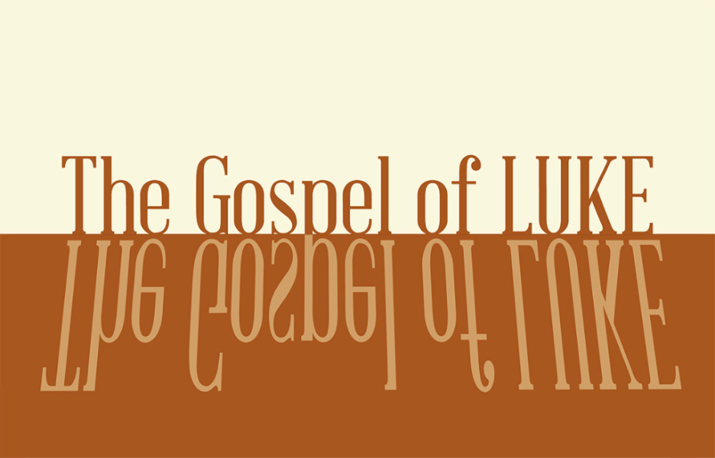

### Slide 1

“When they saw the courage of Peter and John and realized that they were unschooled, ordinary men, they were astonished and they took note that these men had been with Jesus.”

Acts 4:13

### Slide 2

“...a disciple, or apprentice, is simply someone who has decided to be with another person, under appropriate conditions, in order to become capable of doing what that person does or to become what that person is.”

Dallas Willard

### Slide 3

59% of Americans agree that churches and other religious organizations are too concerned with money and power

54% agree that they focus too much on rules

54% agree that they are too involved in politics

pewresearch.org

### Slide 4

"The Son of Man came eating and drinking, and you say, ‘Here is a glutton and a drunkard, a friend of tax collectors and sinners’” (Luke 7:34).

### Slide 5

27 After this, Jesus went out and saw a tax collector by the name of Levi sitting at his tax booth. “Follow me,” Jesus said to him, 28 and Levi got up, left everything and followed him. 29 Then Levi held a great banquet for Jesus at his house, and a large crowd of tax collectors and others were eating with them. 30 But the Pharisees and the teachers of the law who belonged to their sect complained to his disciples, “Why do you eat and drink with tax collectors and sinners?” 31 Jesus answered them, “It is not the healthy who need a doctor, but the sick. 32 I have not come to call the righteous, but sinners to repentance” (Lk 5:27–32).

### Slide 6

“Next to murderers and thieves, tax collectors represent the class that all Jews, even those of low status, would write off as disgraceful, unclean, and irredeemable.”

Diane Chen

### Slide 7

27 After this, Jesus went out and saw a tax collector by the name of Levi sitting at his tax booth. “Follow me,” Jesus said to him, 28 and Levi got up, left everything and followed him. 29 Then Levi held a great banquet for Jesus at his house, and a large crowd of tax collectors and others were eating with them. 30 But the Pharisees and the teachers of the law who belonged to their sect complained to his disciples, “Why do you eat and drink with tax collectors and sinners?” 31 Jesus answered them, “It is not the healthy who need a doctor, but the sick. 32 I have not come to call the righteous, but sinners to repentance” (Lk 5:27–32).

### Slide 8

1/ Receive the welcome of Jesus

2/ Extend the welcome of Jesus

### Slide 9

1/ Receive the welcome of Jesus

### Slide 10

1/ Receive the welcome of Jesus

27 After this, Jesus went out and saw a tax collector by the name of Levi sitting at his tax booth. “Follow me,” Jesus said to him, 28 and Levi got up, left everything and followed him.

### Slide 11

2/ Extend the welcome of Jesus

### Slide 12

2/ Extend the welcome of Jesus

29 Then Levi held a great banquet for Jesus at his house, and a large crowd of tax collectors and others were eating with them.

### Slide 13

“Hospitality involves welcoming, creating space, listening, paying attention, and providing. Meals slow things down. Some of us don’t like that. We like to get things done. But meals force you to be people oriented instead of task oriented.”

T. Chester



## PROFESSION OF FAITH

The Apostle’s Creed

### ALL

I believe in God, the Father almighty,

creator of heaven and earth.

I believe in Jesus Christ, God's only Son, our Lord,

who was conceived by the Holy Spirit,

born of the Virgin Mary,

suffered under Pontius Pilate,

was crucified, died, and was buried;

he descended to the dead.

On the third day he rose again;

he ascended into heaven,

he is seated at the right hand of the Father,

and he will come to judge the living and the dead.

I believe in the Holy Spirit,

the holy catholic Church,

the communion of saints,

the forgiveness of sins,

the resurrection of the body,

and the life everlasting. Amen.

## THE LORD’S SUPPER

### 1 Corinthians 11:23–26

The Lord Jesus, on the night when he was betrayed took bread and when he had given thanks, he broke it and said, “This is my body which is broken for you. Do this in remembrance of me.” In the same way also he took the cup, after supper, saying, “This cup is the new covenant in my blood. Do this as often as you drink it, in remembrance of me."



## HYMN

### The Lord Is My Salvation

© 2016 Capitol CMG Paragon; Getty Music Publishing; Son of the Lion; Sweater Weather Music CCLI Song # 7119942

The grace of God has reached for me

And pulled me from the raging sea

And I safe in this solid ground

The Lord is my salvation

I will not fear when darkness falls

His strength will help me scale these walls

I’ll see the dawn of the rising son

The Lord is my salvation

Who is like the Lord our God?

Strong to save faithful in Love

My debt is paid and the victory won

The Lord is my salvation

My hope is hidden in the Lord

He flow’rs each promise of his Word

When winter fades I know spring will come

The Lord is my salvation

In times of waiting times of need

When I know loss when I am weak

I know his grace will renew these days

The Lord is my salvation

Who is like the Lord our God?

Strong to save faithful in Love

My debt is paid and the victory won

The Lord is my salvation

And when I reach my final day

He will not leave me in the grave

But I will rise He will call me home

The Lord is my salvation

Who is like the Lord our God?

Strong to save faithful in Love

My debt is paid and the victory won

The Lord is my salvation

Who is like the Lord our God?

Strong to save faithful in Love

My debt is paid and the victory won

The Lord is my salvation

Glory be to God the father

Glory be to God the son

Glory be to God the spirit

The Lord is our salvation

Glory be to God the father

Glory be to God the son

Glory be to God the spirit

The Lord is our salvation

Who is like the Lord our God?

Strong to save faithful in Love

My debt is paid and the victory won

The Lord is our salvation



## BENEDICTION

May the Lord of all compassion satisfy you in the morning with his steadfast love, so that you may rejoice and be glad all your days. May the favor of the Lord our God be upon you, and may the work of your hands prosper.

## HOPE HAPPENINGS

### CARMEN HOUSE SPEAKER SERIES

**March 21, 2025 at COHatch Gateway, 6:30–8:00 p.m.**

Speaker Dr. Ben Burkholder “Why Does Virtue Still Matter in a Secular Age? Reflections on Aristotle and Aquinas for the 21st Century”

**April 18, 2025 @COHatch Gateway, 4:30–5:45 p.m.**

Speaker Dylan Crosson “We Call This Friday Good: How have Christians observed Good Friday & why does it matter?”

### OSU STUDENT SUNDAY

**March 30, 2025**

* Cru’s worship band will help lead Hope in worship.
* We’ll hear how God has been at work in the lives of students.
* Free lunch after church for all OSU students.

### MY VILLAGE MINISTRIES TRAINING

Hope partners with My Village Ministries (MVM) to come alongside families in crisis, and provides community to help them get to the other side. Training is required for roles that work directly with families and children; the next volunteer training is Saturday, April 26 from 9am-4pm at The Well

Three Creeks in Gahanna. If you have any questions about MVM, joining our team, or upcoming training events, please reach out to Rebekah Robinson ([rebekaherobinson@gmail.com](mailto:rebekaherobinson@gmail.com)) or Rachel Longo ([rachel.anne.longo@gmail.com](mailto:rachel.anne.longo@gmail.com)). QR code leads to <https://app.aplos.com/aws/events/my_village_training_the_well_three_creeks>.

### HELP HOPE SHOW THE WELCOME OF JESUS: TWO OPPORTUNITIES TO PROVIDE FOOD

Please consider helping contribute to our fellowship events by providing food.

1. Student Sunday—March 30th

2. Easter Sunday Brunch—April 20th

QR Code leads to <https://m.signupgenius.com/#!/showSignUp/30E0F4AA8AD2CA6F94-55587107-hope>.

### HOLY WEEK

April 13—Palm Sunday Service

April 18—Good Friday Service at Scarlet City

April 20—Easter Sunday Service & Brunch

## Digital Connect Card

We’re glad you’re here! Let’s stay connected; please fill out the form at the following link: <https://hopechurchcolumbus.churchcenter.com/people/forms/281549>.