

Hope Presbyterian Church Accessible Worship Folder and Slide Deck Transcription
May 11, 2025
www.hopechurchcolumbus.org
Pastor—Joe Haack—joe@hopechurchcolumbus.org
Youth Pastor—Wes Piehl—wes@hopechurchcolumbus.org
Deacons—deacons@hopechurchcolumbus.org
Operations Manager—Nichole Redinger—operations@hopechurchcolumbus.org
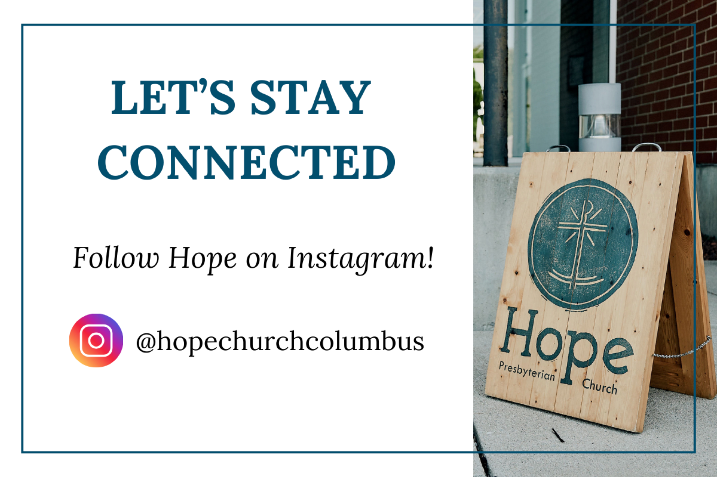

CALL TO WORSHIP
Psalm 95:1-7, NLT

LEADER
Come, let us sing to the LORD! Let us shout joyfully to the Rock of our salvation.

ALL
Let us come to him with thanksgiving. Let us sing psalms of praise to him.

LEADER
For the LORD is a great God, a great King above all gods. He holds in his hands the depths of the earth and the mightiest mountains. The sea belongs to him, for he made it. His hands formed the dry land, too.

ALL
Come, let us worship and bow down. Let us kneel before the LORD our maker, for he is our God. We are the people he watches over, the flock under his care.

DOXOLOGY
Lyrics: Thomas Ken, 1674
Praise God from whom all blessings flow;
Praise him all creatures here below;
Praise him above, ye heavenly host;
Praise Father, Son, and Holy Ghost.
Amen.

Prayer of Invocation

LEADER
God, our Rock, our refuge, our resting place, we come to you. Out of another busy week of work, out of our struggles to be meaningful in our world, out of our desire to meet you and know you as the center of our being, we come to you, O unmovable Rock of our security. Amen.

HYMN

Almighty God
CCLI Song # 7019312
David Leonard | Leslie Jordan | Sandra McCracken
Almighty God, to You all hearts are open
Search and know our thoughts and anxious fears
Wash us in the fountain of Your mercy
Come with Your light We cannot hide from You
Almighty God, to You all hearts are open
With gratitude we raise a song to You
Come and feel the praises of Your people
In grace and truth You make us new again
Hallelujah
Hallelujah
Hallelujah
Almighty God, to You all hearts are open
We long for more than what this world provides
No shallow spring will ever satisfy us
But Your river deep floods over everything
Hallelujah
Hallelujah
Hallelujah
Almighty God, to You all hearts are open
You take away our sickness and our sin
Oh Lamb of God we gather at Your table
In bread and wine you satisfied our need
Hallelujah
Hallelujah
Hallelujah
Almighty God, to You all hearts are open

Prayer of Remembrance
Psalm 139:13–18, NLT

ALL
You made all the delicate, inner parts of my body and knit me together in my mother’s womb. Thank you for making me so wonderfully complex!
Your workmanship is marvelous—how well I know it. You watched me as I was being formed in utter seclusion, as I was woven together in the dark of the womb. You saw me before I was born. Every day of my life was recorded in your book. Every moment was laid out before a single day had passed.

LEADER
How precious are your thoughts about me, O God. They cannot be numbered! I can’t even count them; they outnumber the grains of sand! And when I wake up, you are still with me!

HYMN

O Come To The Altar
CCLI Song # 7051511
Chris Brown | Mack Brock | Steven Furtick | Wade Joye
Are you hurting and broken within?
Overwhelmed by the weight of your sin?
Jesus is calling
Have you come to the end of yourself?
Do you thirst for a drink from the well?
Jesus is calling
O come to the altar
The Father's arms are open wide
Forgiveness was bought with
The precious blood of Jesus Christ
Leave behind your regrets and mistakes
Come today, there's no reason to wait
Jesus is calling
Bring your sorrows and trade them for joy
From the ashes a new life is born
Jesus is calling
O come to the altar
The Father's arms are open wide
Forgiveness was bought with
The precious blood of Jesus Christ
O come to the altar
The Father's arms are open wide
Forgiveness was bought with
The precious blood of Jesus Christ
Oh what a Savior
Isn't He wonderful
Sing Alleluia!
Christ is risen
Bow down before Him
For He is Lord of all
Sing Alleluia!
Christ is risen
Oh what a Savior
Isn't He wonderful
Sing Alleluia!
Christ is risen
Bow down before Him
For He is Lord of all
Sing Alleluia!
Christ is risen
O come to the altar
The Father's arms are open wide
Forgiveness was bought with
The precious blood of Jesus Christ
O come to the altar
The Father's arms are open wide
Forgiveness was bought with
The precious blood of Jesus Christ
Bear your cross as you wait for the crown
Tell the world of the treasure you've found

CONFESSION OF SIN
Based on Romans 5:8; Hebrews 4:16, NRSV

LEADER
The proof of God’s amazing love is this: While we were sinners, Christ died for us.

ALL
Let us therefore approach the throne of grace with boldness, so that we may receive mercy and find grace to help in time of need. Trusting in God’s faithfulness and compassion, let us confess our sin before God and one another.

HYMN

All I Have Is Yours
CCLI Song # 4878364
Bobby Gilles | Rebecca Elliott
Creator Giver of all things
All I have is Yours
Accept my humble offering
All I have is Yours
When I was chained to greed and pride
Tight fisted destined just to die
You paid my debt and bought my life
All I have is Yours
All I have
All I have
All I have is Yours
This offering is a means of grace
All I have is Yours
You show me this to grow my faith
All I have is Yours
The more I give the less I need
I learn that You'll provide for me
'Twas blind to this but now I see
All I have is Yours
All I have
All I have
All I have is Yours
Your kingdom come Your will be done
All I have is Yours
You'll finish all that You've begun
All I have is Yours
That You would use the gifts I bring
In service of the coming King
Is reason now to praise and sing
All I have is Yours
All I have
All I have
All I have is Yours
All I have
All I have
All I have is Yours

GRACE ASSURANCE
Romans 8:1, NET

LEADER
There is therefore now no condemnation for those who are in Christ Jesus.

HYMN

Blessed Assurance
CCLI Song # 7011451
Chris Brown | Fanny Jane Crosby | Mack Brock | Phoebe Palmer Knapp
Blessed assurance Jesus is mine
Oh what foretaste of glory divine
Heir of salvation purchase of God
Born of His Spirit washed in His blood
Perfect submission all is at rest
I in the Savior am happy and blessed
Watching and waiting looking above
Filled with His goodness lost in His love
This is my story this is my song
Praising my Savior all the day long
This is my story this is my song
Praising my Savior all the day long

TITHES AND OFFERINGS
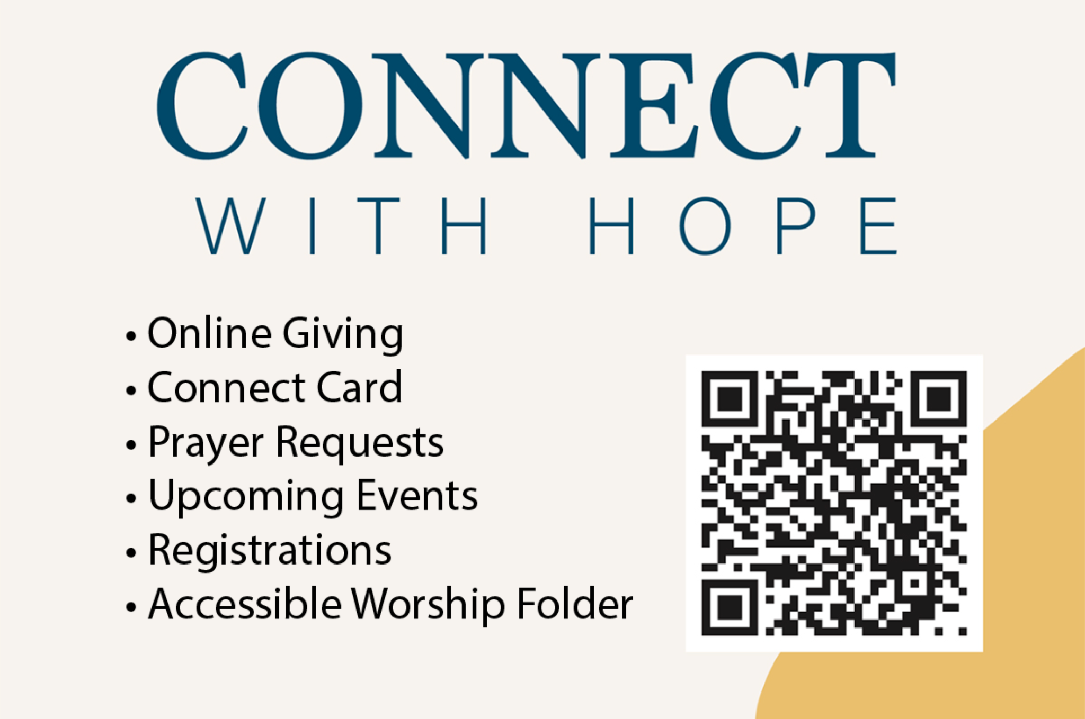

HOPE HAPPENINGS AND ANNOUNCEMENTS

PASSING THE PEACE

SCRIPTURE READING
Luke 7:1-10

LEADER
The Word of the Lord.

ALL
Thanks be to God.

MESSAGE
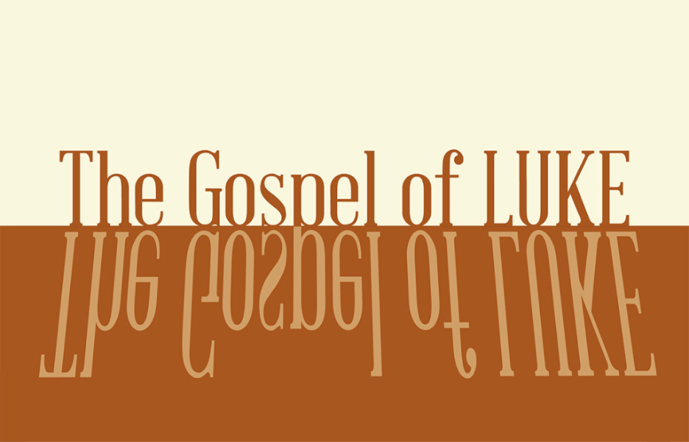

Slide 1
unwritten rules

Slide 2
I'm my mother's child
I'm my father's son
It took me a while
But my time has come
To be born again
To be born again.
-Josh Garrels

Slide 3
“When Jesus had finished saying all this.” -Luke 7:1

Slide 4
The definition of a blessed life is flipped upside-down (6:20-26)
The people who receive our generosity is flipped outside-in (27-36)
The energy of our attention and care is flipped inside-out (37-45)

Slide 5
“Be merciful, just as your Father is merciful.” Luke 6:36

Slide 6
When Jesus had finished saying all this to the people who were listening, he entered Capernaum. 2 There a centurion’s servant, whom his master valued highly, was sick and about to die. 3 The centurion heard of Jesus and sent some elders of the Jews to him, asking him to come and heal his servant. 4 When they came to Jesus, they pleaded earnestly with him, “This man deserves to have you do this, 5 because he loves our nation and has built our synagogue.” Luke 7:1-5

Slide 7
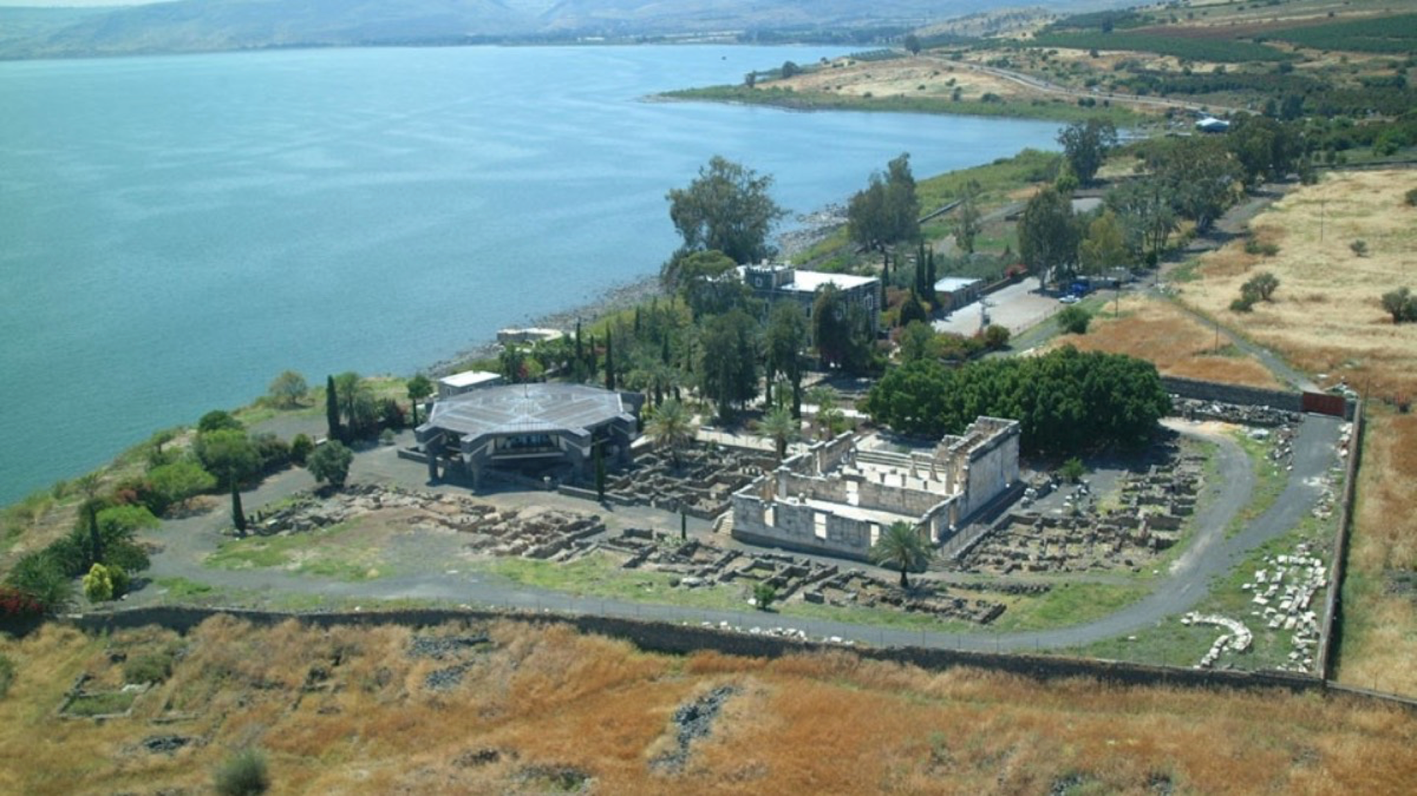

Slide 8
When Jesus had finished saying all this to the people who were listening, he entered Capernaum. 2 There a centurion’s servant, whom his master valued highly, was sick and about to die. 3 The centurion heard of Jesus and sent some elders of the Jews to him, asking him to come and heal his servant. 4 When they came to Jesus, they pleaded earnestly with him, “This man deserves to have you do this, 5 because he loves our nation and has built our synagogue.” Luke 7:1-5

Slide 9


Slide 10
When Jesus had finished saying all this to the people who were listening, he entered Capernaum. 2 There a centurion’s servant, whom his master valued highly, was sick and about to die. 3 The centurion heard of Jesus and sent some elders of the Jews to him, asking him to come and heal his servant. 4 When they came to Jesus, they pleaded earnestly with him, “This man deserves to have you do this, 5 because he loves our nation and has built our synagogue.” Luke 7:1-5

Slide 11
6 So Jesus went with them. He was not far from the house when the centurion sent friends to say to him: “Lord, don’t trouble yourself, for I do not deserve to have you come under my roof. 7 That is why I did not even consider myself worthy to come to you. But say the word, and my servant will be healed. 8 For I myself am a man under authority, with soldiers under me. I tell this one, ‘Go,’ and he goes; and that one, ‘Come,’ and he comes. I say to my servant, ‘Do this,’ and he does it.” 9 When Jesus heard this, he was amazed at him, and turning to the crowd following him, he said, “I tell you, I have not found such great faith even in Israel.” 10 Then the men who had been sent returned to the house and found the servant well. Luke 7:6-10

Slide 12
The unwritten rules of the Roman Empire
1/ “Show no weakness”
2/ “Show no mercy”

Slide 13
show no weakness

Slide 14

Slide 15
embrace weakness

Slide 16
show no mercy

Slide 17

Slide 18
receive and extend mercy

CONFESSION OF FAITH
The Lord’s Prayer

ALL
Our Father in heaven, hallowed be your name, your kingdom come, your will be done, on earth as in heaven. Give us today our daily bread. Forgive us our sins as we forgive those who sin against us. Lead us not into temptation but deliver us from evil. For the kingdom, the power, and the glory are yours now and forever. Amen.

THE LORD’S SUPPER

1 Corinthians 11:23–26
The Lord Jesus, on the night when he was betrayed took bread and when he had given thanks, he broke it and said, “This is my body which is broken for you. Do this in remembrance of me.” In the same way also he took the cup, after supper, saying, “This cup is the new covenant in my blood. Do this as often as you drink it, in remembrance of me."

HYMN

Great Is Thy Faithfulness
CCLI Song # 7187517
Shane Barnard
Great is Thy faithfulness
O God my Father
There is no shadow
Of turning with Thee
Thou changest not
Thy compassions they fail not
As Thou hast been
Thou forever will be
Great is Thy faithfulness!
Great is Thy faithfulness!
Morning by morning
New mercies I see
All I have needed
Thy hand hath provided
Great is Thy faithfulness
Lord unto me
I could not love Thee
So blind and unfeeling
Covenant promises meant naught to me
Then without warning, desire, or deserving
I found my treasure
My pleasure in Thee
Great is Thy faithfulness!
Great is Thy faithfulness!
Morning by morning
New mercies I see
All I have needed
Thy hand hath provided
Great is Thy faithfulness
Lord unto me
I have no merit
To woo or delight Thee
I have no wisdom
Or pow’rs to employ
Yet in Thy mercy
How pleasing Thou find’st me
This is Thy pleasure
That Thou art my joy
Great is Thy faithfulness!
Great is Thy faithfulness!
Morning by morning
New mercies I see
All I have needed
Thy hand hath provided
Great is Thy faithfulness
Lord unto me
Pardon for sin
And a peace that endureth
Thine own dear presence
To cheer and to guide
Strength for today
And bright hope for tomorrow
Blessings all mine
With ten thousand beside
Great is Thy faithfulness!
Great is Thy faithfulness!
Morning by morning
New mercies I see
All I have needed
Thy hand hath provided
Great is Thy faithfulness
Lord unto me
Great is Thy faithfulness!
Great is Thy faithfulness!
Morning by morning
New mercies I see
All I have needed
Thy hand hath provided
Great is Thy faithfulness
Great is Thy faithfulness
Great is Thy faithfulness
Lord unto me

BENEDICTION
Ephesians 3:20-21, NRSV
Now to him who by the power at work within us is able to accomplish abundantly far more than all we can ask or imagine, to him be glory in the church and in Christ Jesus to all generations, forever and ever. Amen.

HOPE HAPPENINGS

HOPE KIDS-TEACHERS NEEDED
We are in need of several teachers for children’s church. Please contact Wes at wes@hopechurchcolumbus.org if you are interested in serving.

SET-UP TEAM HELP NEEDED
Meeting in the 4-H Building comes with unique challenges, the largest being that we need to set-up and tear down the sanctuary each week. The Set-Up team is in need of a few more volunteers. Please consider serving Hope in this way, it is usually a once-a-month commitment. Contact Ryan McNamara to learn more. ryan.mcnamara22@gmail.com

MAY 25th, 2025
Join us as we welcome several people in our Hope family to membership during the service!

Digital Connect Card
We’re glad you’re here! Let’s stay connected; please fill out the form at the following link: https://hopechurchcolumbus.churchcenter.com/people/forms/281549.

