

Hope Presbyterian Church Accessible Worship Folder and Slide Deck Transcription
November 17, 2024
www.hopechurchcolumbus.org
Pastor—Joe Haack—joe@hopechurchcolumbus.org
Youth Pastor—Wes Piehl—wes@hopechurchcolumbus.org
Deacons—deacons@hopechurchcolumbus.org
Operations Manager—Nichole Redinger—operations@hopechurchcolumbus.org


Call to Worship
Psalm 34:3, 8, 5

LEADER
Oh, magnify the Lord with me, and let us exalt His name together! Oh, taste and see that the Lord is good!

ALL
Those who look to Him are radiant, and their faces shall never be ashamed.

DOXOLOGY
Lyrics: Thomas Ken, 1674
Praise God from whom all blessings flow;
Praise him all creatures here below;
Praise him above, ye heavenly host;
Praise Father, Son, and Holy Ghost.
Amen.

HYMNS

Jesus, What a Friend for Sinners
CCLI Song # 4989686
John Wilbur Chapman | Matthew S. Smith | Rowland Hugh Prichard
Jesus! What a friend for sinners!
Jesus! Lover of my soul;
Friends may fail me, foes assail me,
He, my Savior, makes me whole.
Hallelujah! What a Savior!
Hallelujah! What a friend!
Saving, helping, keeping, loving,
He is with me to the end.
Jesus! What a strength in weakness!
Let me hide myself in Him.
Tempted, tried, and sometimes failing,
He, my strength, my victory wins.
Hallelujah! What a Savior!
Hallelujah! What a friend!
Saving, helping, keeping, loving,
He is with me to the end.
Jesus! What a help in sorrow!
While the billows over me roll,
Even when my heart is breaking,
He, my comfort, helps my soul.
Hallelujah! What a Savior!
Hallelujah! What a friend!
Saving, helping, keeping, loving,
He is with me to the end.
Jesus! I do now receive Him,
More than all in Him I find.
He hath granted me forgiveness,
I am His, and He is mine.
Hallelujah! What a Savior!
Hallelujah! What a friend!
Saving, helping, keeping, loving,
He is with me to the end.

Run To The Father
CCLI Song # 7133494
Cody Carnes | Matt Maher | Ran Jackson
I’ve carried a burden for too long on my own
I wasn’t created to bear it alone
I hear Your invitation to let it all go
I see it now, I’m laying it down
I know that I need You
I run to the Father, I fall into grace
I’m done with the hiding, no reason to wait
My heart needs a surgeon
My soul needs a friend
So I’ll run to the Father, again and again
And again and gain
You saw my condition
Had a plan from the start
Your Son for redemption
The price for my heart
I don’t have a context for that kind of love
I don’t understand, I can’t comprehend
All I know is I need You
I run to the Father, I fall into grace
I’m done with the hiding, no reason to wait
My heart needs a surgeon
My soul needs a friend
So I’ll run to the Father, again and again
And again and again
My heart has been in Your sights
Long before my first breath
Running into Your arms
Is running to life from death
I feel this rush deep in my chest
Your mercy is calling out Just as I am,
You pull me in I know I need You now
I run to the Father, I fall into grace
I’m done with the hiding, no reason to wait
My heart found a surgeon
My soul found a friend
So I’ll run to the Father, again and again
And again and again
I run to the Father, I fall into grace
I’m done with the hiding, no reason to wait
My heart found a surgeon
My soul found a friend
So I’ll run to the Father, again and again
And again and again

CONFESSION OF SIN

LEADER
Almighty God, you have raised Jesus from death to life and crowned him Lord of all. We confess that we have not bowed before him or acknowledged his rule in our lives.

ALL
Forgive us and raise us from sin, that we may be your faithful people, obeying the commands of our Lord Jesus Christ, who rules the world and is head of the church. Amen.

HYMN

I Boast No More
CCLI Song # 3420775 Isaac Watts | Sandra McCracken
No more, my God, I boast no more
Of all the duties I have done;
I quit the hopes I held before,
To trust the merits of Thy Son
No more my God,
No more my God,
No more my God,
I boast no more.
Now, for the loss I bear His name,
What was my gain I count my loss;
My former pride I call my shame,
And nail my glory to His cross.
No more my God,
No more my God,
No more my God,
I boast no more.
Yes, and I must and will esteem
All things but loss for Jesus’ sake;
O may my soul be found in Him,
And of His righteousness partake!
No more my God,
No more my God,
No more my God,
I boast no more.
The best obedience of my hands
Dares not appear before Thy throne;
But faith can answer Thy demands,
By pleading what my Lord has done.
No more my God,
No more my God,
No more my God,
I boast no more.
No more my God,
No more my God,
No more my God,
I boast no more.

GRACE ASSURANCE

LEADER
Take comfort in the assurance that even those things that are hidden from memory, or are too deep for our words, are not beyond God’s forgiving love.

ALL
God, who knows us completely, bestows pardon and peace. Thanks be to God!

HYMN

MY ONE COMFORT
CCLI Song # 7004662 Dustin Kensrue
My one comfort both in life and death
Is that I am not my own
I was bought with blood and I confess
I belong to You alone
By the Father’s good decree
Jesus You’ve delivered me
By Your Spirit set me free
To follow You
My one comfort both in life and death
Is that I am not my own
I was bought with blood and I confess
I belong to You alone
By the Father’s good decree
Jesus You’ve delivered me
By Your Spirit set me free
To follow You
Jesus You have taken hold of me
And in Your grip of grace
I’m finally free
By the Father’s good decree Jesus
You’ve delivered me
By Your Spirit set me free
To follow You

TITHES AND OFFERINGS


HOPE HAPPENINGS AND ANNOUNCEMENTS

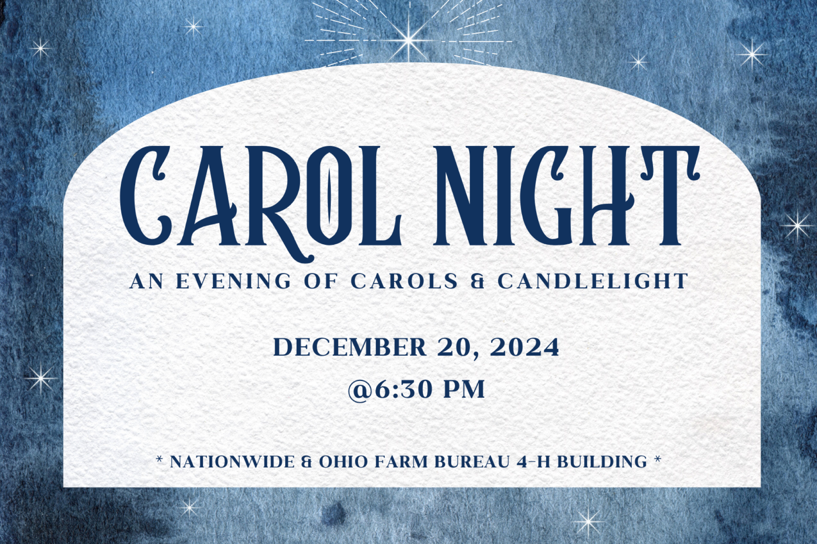


PASSING THE PEACE

SCRIPTURE READING
Isaiah 58:1–9a

MESSAGE

Slide 1


Slide 2
"In the 150s Justin (martyred 165) wrote a reasoned defense of Christianity - an Apology - directed to the emperor Antoninus Pius. In it he contends that the Christians are growing in numbers because their lives embody 'the fair commands of Christ.' In the Christians who follow Jesus their critics encounter a 'good hope' that attracts them.”

Slide 3
“The sources rarely indicate that the early Christians grew in number because they won arguments; instead they grew because their habitual behavior (rooted in patience) was distinctive and intriguing. Their habitus... enabled them to address intractable problems that ordinary people faced in ways that offered hope. When challenged about their ideas, Christians pointed to their actions. They believed that their habitus, their embodied behavior, was eloquent. Their behavior said what they believed; it was an enactment of their message. And the sources indicate that it was their habitus more than their ideas that appealed to the majority of the non-Christians who came to join them."
Alan Kreider, Patient Ferment of the Early Church

Slide 4
Do Christians Really Change?

Slide 5
"Nothing is more repulsive and more steadily offensive to those who do not as yet believe than the unspirituality of those who believe...
They feel inclined to accept your sacred mysteries provided they can but discover that sacred power goes out from you. And when they see that there is no such power, that the good works which they expect from you are not forthcoming, that this higher seriousness of life is not in evidence; when on the contrary they constantly hear of hypocrites who present themselves in good form, and then prove themselves inferior in character and in their inner life to those who make no profession of the faith, they are offended by it and this holds them back from Christ.”
- Abraham Kuyper, To Be Near Unto God

Slide 6
1. Not all who say “Lord, Lord”

Slide 7
“Not everyone who says to me, ‘Lord, Lord,’ will enter the kingdom of heaven, but the one who does the will of my Father who is in heaven. 22 On that day many will say to me, ‘Lord, Lord, did we not prophesy in your name, and cast out demons in your name, and do many mighty works in your name?’ 23 And then will I declare to them, ‘I never knew you; depart from me, you workers of lawlessness.’”
Mt. 7:21-23 (ESV)

Slide 8
"Justin notes that his community doesn't consider people true Christians if they simply quote Christ's teachings but don't live them. Jesus himself had insisted on this: ‘Not everyone who says to me, Lord, Lord... but only the one who does the will of my Father’ (Matt. 7:21). Further, Justin believes that the effectiveness of Christian witness depends on the integrity of the believers' lifestyles."
-Alan Kreider, Patient Ferment of the Early Church

Slide 9
1. Not all who say “Lord, Lord”
2. Regeneration ≠ Sanctification

Slide 10
Therefore, my beloved, as you have always obeyed, so now, not only as in my presence but much more in my absence, work out your own salvation with fear and trembling, 13 for it is God who works in you, both to will and to work for his good pleasure.
Phil. 2: 12-13 (ESV)

Slide 11
"A word about patience is in order. Living a good, beautiful, and kind life—the way of Christ's love—is not something that happens overnight.
Love is a fruit of the Holy Spirit; that is to say, it grows slowly. There is no shortcut to love. The assumption that many carry is that God can produce something in us quickly, but fruit is grown over time. The gifts of the Spirit are given generously and quickly. Not so with the fruit of the Spirit.
One of the dangers is we expect the gifts of the Spirit to quickly do what only the fruit of the Spirit is meant to do slowly. "
-Rich Villodas, Good and Beautiful and Kind

Slide 12
1. Not all who say “Lord, Lord”
2. Regeneration ≠ Sanctification
3. Spiritual Practices Matter

Slide 13
And we all, with unveiled face, beholding the glory of the Lord, are being transformed into the same image from one degree of glory to another. For this comes from the Lord who is the Spirit.
2 Cor 3. 18 (ESV)

Slide 14
"All of us learn to interact and to communicate by following a script. This script is most likely unconscious; we may have inherited it from our parents or picked it up from friends, movies, or our particular subculture. But these habits—our particular patterns of thinking, speaking, and listening—move us, bit by bit, toward or away from love... But what if prayer is more than simply self-expression? What if prayer is a kind of craft or exercise that shapes us? What if God uses prayer to “act back on us,” to form us? What if set liturgical prayers are an ancient tool that reframe our perspectives and desires so that we might learn to pray in ways that are beyond us?”
Tish Harrison Warren

Slide 15


Photo of prayer book called “Seeking God’s Face: Praying with the Bible Through the Year”

Slide 16

PROFESSION OF FAITH
My only comfort in life and in death is that I am not my own, but belong—body and soul, in life and in death—to my faithful Savior Jesus Christ. He has fully paid for all my sins with his precious blood, and has set me free from the tyranny of the devil. He also watches over me in such a way that not a hair can fall from my head without the will of my Father in heaven: in fact, all things must work together for my salvation. Because I belong to him, Christ, by his Holy Spirit, assures me of eternal life and makes me wholeheartedly willing and ready from now on to live for him.
—from Heidelberg Catechism, Q&A 1

THE LORD’S SUPPER

1 Corinthians 11:23–26
The Lord Jesus, on the night when he was betrayed took bread and when he had given thanks, he broke it and said, “This is my body which is broken for you. Do this in remembrance of me.” In the same way also he took the cup, after supper, saying, “This cup is the new covenant in my blood. Do this as often as you drink it, in remembrance of me."

HYMN

SHALL WE GATHER?
CCLI Song # 93731 Robert Lowry
Shall we gather at the river
Where bright angel feet have trod
With its crystal tide forever
Flowing by the throne of God
On the margin of the river
Washing up its silver spray
We will talk and worship ever
All the happy golden day
Yes, we'll gather at the river
Gather at the river
We will gather at the river
By the throne of God
Yes, we'll gather at the river
Gather at the river
We will gather at the river
By the throne of God
Ere we reach the shining river
We’ll lay every burden down
Grace our spirits will deliver
And provide a robe and crown
At the smiling of the river
Mirror of the Saviors face
Saints whom death will never sever
Lift their songs of saving grace
Yes, we'll gather at the river
Gather at the river
We will gather at the river
By the throne of God
Yes, we'll gather at the river
Gather at the river
We will gather at the river
By the throne of God
Soon we’ll reach the silver river
Soon our pilgrimage will cease
Soon our happy songs will quiver
With a melody of peace
Yes, we'll gather at the river
Gather at the river
We will gather at the river
By the throne of God
Yes, we'll gather at the river
Gather at the river
We will gather at the river
By the throne of God

BENEDICTION
Let the beloved of the Lord rest secure in Him, Let Him shield them all day long, Let the one the Lord loves rest between His shoulders. That you might be steadfast, immovable and knowing that your toil in the Lord is not in vain, today and forevermore.

HOPE HAPPENINGS

Women’s Christmas Party & Mug Swap
Saturday, December 7 at 10 a.m. Join us for a festive brunch and mug swap. Select a mug from your cupboard to exchange and return home with a new-to-you mug! Get creative or cozy, funny or fancy, classic or weird!
At the Piehl Home 5364 Amy Lane, 43235. Text Michelle at 419–215–7848
RSVP at https://hopechurchcolumbus.churchcenter.com/registrations/events/2569217.

Hope Youth Bonfire Night
Sunday, November 17, 2024 at 6:30–8 p.m. at the Piehl Home

Carol Night
Friday, December 20, 2024 at 6:30 p.m.
Nationwide & Ohio Farm Bureau 4-H Center
Invite your friends & family to our annual evening of carols & candlelight! The service will be followed by a time for fellowship & treats. All are invited to bring Christmas treats to share!

Digital Connect Card
We’re glad you’re here! Let’s stay connected; please fill out the form at the following link: https://hopechurchcolumbus.churchcenter.com/people/forms/281549.

