
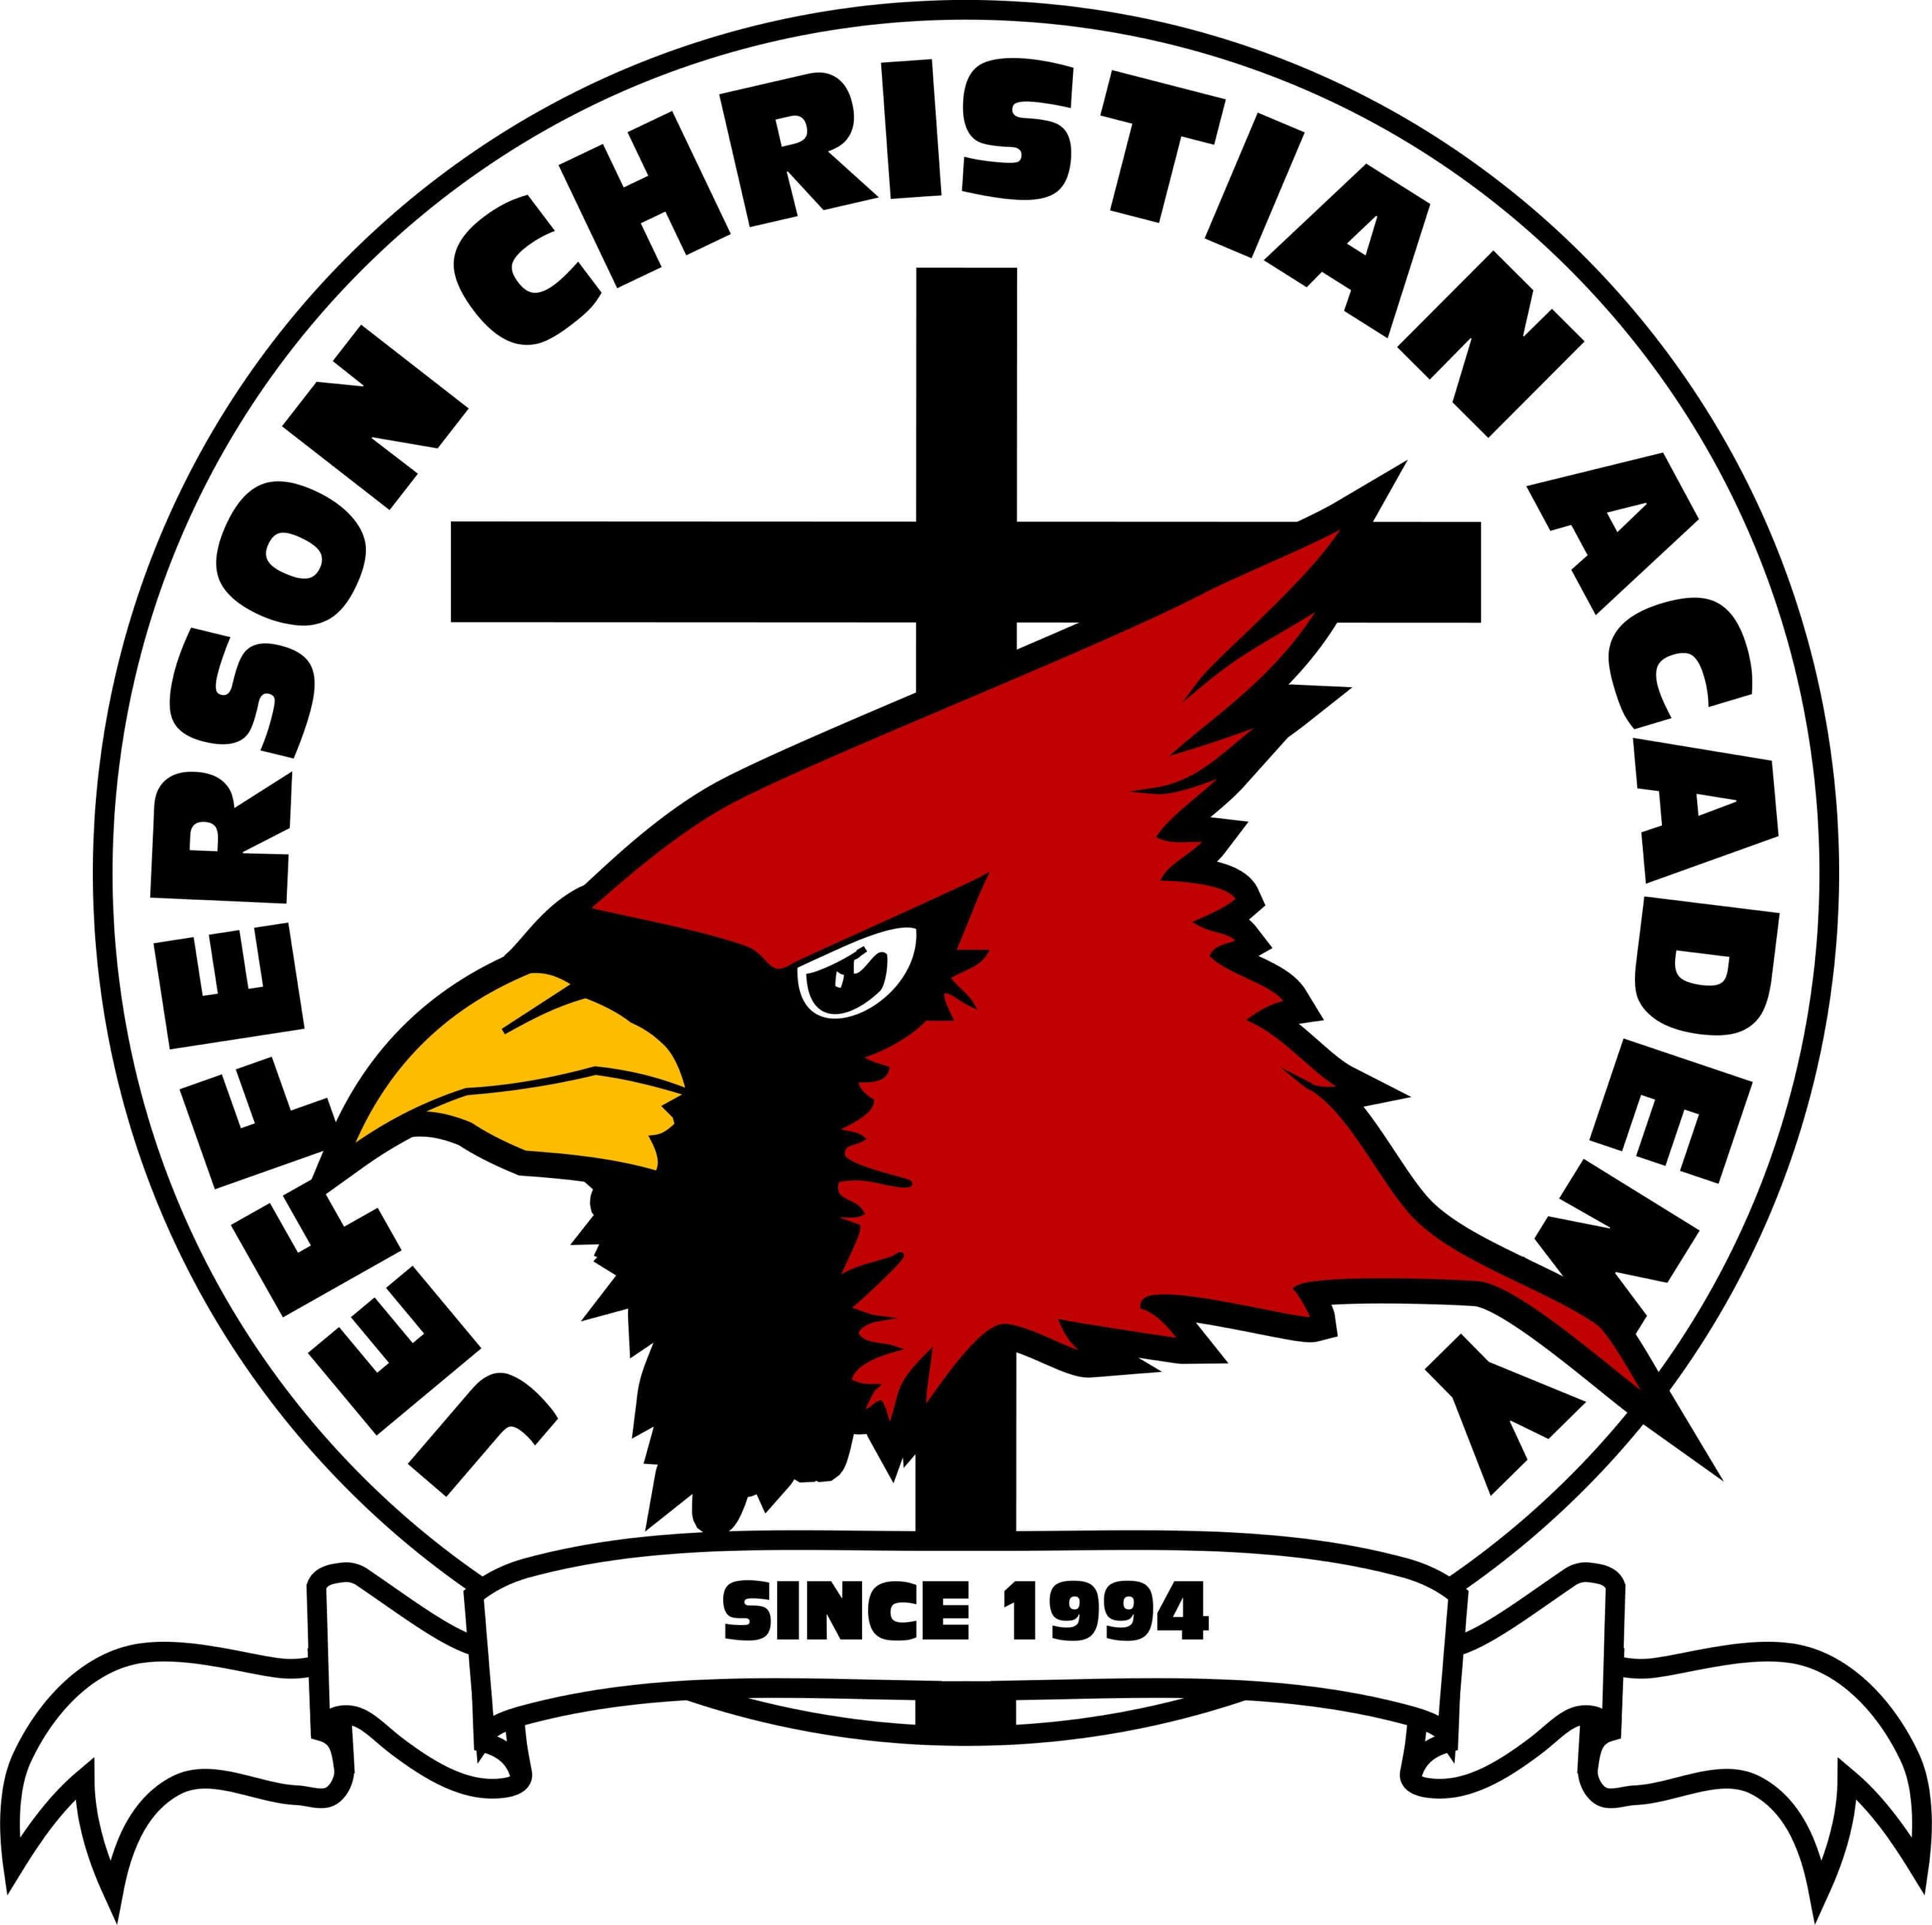
JEFFERSON CHRISTIAN ACADEMY
219 Big Stony Creek Road, Ripplemead, VA 24150
Phone: 540.626.5222 Ext. 228
Email: office@jcatoday.org, Website: www.jcatoday.org

Dear Parents,

I would like to cordially invite your child to come be a part of K5 Day at Jefferson Christian Academy! This is a wonderful opportunity for your child to experience a day in kindergarten. Our K5 Day is scheduled for Wednesday, March 11, from 8:30 am-12:15 pm. In the event of a snow day or a 2-hour delay, the make-up day is scheduled for Wednesday, March 18. The schedule for the half day is below. Please pack your child a bag lunch for their visit.


8:15-8:30 Drop Off
8:30-8:45 Arrival/Unpack/
Playdoh Tablework
8:45-9:05 Carpet Time,
Scavenger Hunt, Potty
9:05-9:45 Chapel
9:45-11:00 Crafts
11:00-12:15 Lunch and Recess
12:15 Parent Pick-Up

Our mission at JCA is simple…. Like the third leg of a three-legged stool, our goal is to support and reinforce what our children are taught by their families and home church. Psalm 111:10 says, “The fear of the Lord is the beginning of wisdom…” It is our mission to give not only a challenging and well-rounded education but to also provide a Christian worldview to our students and to encourage them to continue to serve the Lord throughout their life. K5-5th grade students are taught using the Abeka curriculum. If you have any questions about curriculum, feel free to ask at any time. Our Statement of Faith is also attached.

We know that planning for kindergarten is an exciting milestone for every family. Parents will have an opportunity to tour our campus and meet our staff at our Fine Arts Night event Friday, February 27th from 6:30-8:30 pm. This event showcases the talents of our students as they prepare for regional competition. For more information on our school, we also encourage you to look at our website at www.jcatoday.org.

Please fill out the registration form provided, including JCA’s Statement of Faith, and return it to our office by Thursday, March 6. Packets may be turned in to Mrs. Carter (if the student is currently enrolled at TLC Preschool) or to our JCA office. We are looking forward to a FUN-FILLED DAY in Kindergarten!! (Remember to pack a lunch!) We hope you will join us!!

Mrs. Kim Breeding
Kindergarten Teacher

K5 Day Registration for March 11

Parent’s Names _______________________________________________________________________
Child’s Name __________________________________________ Date of Birth ___________________
Address _____________________________________________________________________________
Phone ____________________________ Email ___________________________________________
Emergency Contact ________________________________________ Phone # ____________________
Allergies or Medical Needs we should be aware of _________________________________________

JCA STATEMENT OF FAITH
Convinced that the Bible is the complete, inspired Word of God and our sole authority for faith and practice, the Academy affirms the following truths:
- We believe the Word of God is the foundation of all truth.
- We believe in the Triune God – God the Father, God the Son, and God the Holy Spirit.
- We believe in the virgin birth of Jesus Christ, the only begotten Son of God.
- We believe in His sinless life, His vicarious atonement for the sins of mankind by the shedding of His blood on the cross.
- We believe in His bodily resurrection from the dead and His imminent return to earth for His saints.
- We believe that God is the Creator and Sustainer of all things. We believe the Genesis account of creation in which the universe was made in six days of twenty-four hours each. We believe in the creation of man as a direct act of God.
- We believe that man, having rebelled and fallen from his blessed state with God, is morally and spiritually depraved. He is a sinner by birth and by choice. We believe in the salvation of men by faith alone in Jesus Christ.
- We believe in the saved going to a literal Heaven for eternity, and the unsaved going to a literal Hell for eternity.
- We believe our unity is found in the person of Jesus Christ who is “the way, the truth and the life” (John 14:6).
- We believe that God has commanded that no intimate sexual activity be engaged in outside of a marriage between one man and one woman. We believe that any form of sexual immorality; including homosexuality, lesbianism, bisexuality, incest, fornication, adultery, and pornography are sinful perversions of God’s gift of sex. We believe that God disapproves of and forbids any attempt to alter one’s gender by surgery or appearance. We believe that God disapproves of transgenderism. (Gen. 2:24; Gen. 19:5, 13; Gen. 26:8-9; Lev. 18:1-30; Rom. 1: 26-29; 1 Cor. 5:1; 6:9; 1 Thess. 4:1-8; Heb. 13:4)
- We believe that the only Biblical marriage is the joining of one natural man and one natural woman. We believe that a person’s gender is defined by the God-given biological gender at birth. (Gen. 2:24; Rom. 7:2; 1 Cor. 7:10; Eph. 5:22-23)

Immoral Behavior

Physical Contact/Immorality
Behavior should be above reproach. In accordance with the ministry’s statement of faith and in recognition of Biblical commands, no immoral conduct will be tolerated. The Bible strictly forbids such conduct which includes immoral actions as well as advocating for sinful behavior. The following will not be tolerated in any form and will constitute grounds for expulsion: and actions or identifying statements advocating fornication, adultery, homosexuality, lesbianism, bisexuality, transgenderism, or pornography. (Gen. 2:24; Gen. 19:5, 13; Gen. 26:8-9; Lev. 18:1-30; Rom. 1:26-29; I Cor. 5:1; I Cor. 6:9; I Thess. 4:1-8; Heb. 13:4)

Definition of “Immoral Act”
Bodily contact, actively undertaken or passively permitted between members of the opposite sex or members of the same sex for the purpose of satisfying sexual desires and any bodily contact that a reasonable person would understand to demonstrate a propensity or intent to engage in an immoral or homosexual act.

Nothing will be taught at Jefferson Christian Academy that in any way contradicts the express beliefs of Riverview Baptist Church.

By signing this document, I/WE am/are affirming agreement with and willingness to support these beliefs of Jefferson Christian Academy’s (a ministry of Riverview Baptist Church) Statement of Faith.

Father Signature: ____________________________________________________________ Date: ___________________
Mother Signature: ___________________________________________________________ Date: ___________________

