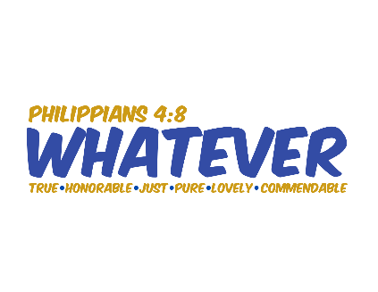
Summer Camp 2025 registration begins soon! Join Camp Manitoqua & Retreat Center this summer as they teach campers to think about and live out God’s truth “Whatever” the situation using Philippians 4:8. We are so thankful for the truth that God gives us in his word and we are so thankful for the chance to share it with your campers this summer. If you want to read more about the programs, visit Manitoqua.org/summer or call the camp office at 815.469.2319 with questions. Registration for the overnight programs begin on Wednesday, March 6th at 6:00am.
