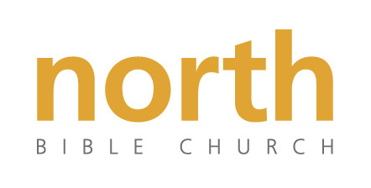
North Bible Church

New Member Form

Name ____________________________________________ Telephone __________________

Address ____________________________ City _____________________ Zip ____________

E-Mail ________________________________________________________________________

Briefly describe how, when and where you trusted Christ alone for the forgiveness of your sins:

_________________________________________________________________________________________________________________________________________________________________________________________________________________________________________________________________________________________________________________________________________________________________________________________________________________________________________________________________________________________________________________________________________________________________________________________________________________________________________________________________________________________________________________________________________________________________________________________________________________________________________________________________________________________________________________________________________________________________________________________________________________________________________________________________________________________________________________________________________________________________________________________________________________________________

I have been baptized since accepting Christ as my Savior (If yes, when and where)

______Yes: Year:__________ Location:_______________________________
______No
______I am willing to be baptized in the near future

Comments:

____________________________________________________________________________________________________________________________________________________________________________________________________________________________________________________________________________________________________________________________

I have read and agree with North Bible Church’s Statement of Faith

Name _________________________________________________________________
(Please Print)

_________________________________________________ ____________________
Signature Date

Thank you for your desire to become a participating member of North Bible Church.

