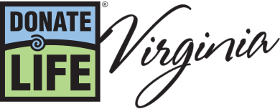

Why become an organ donor?
- The need is tremendous: Over 106,000 people in the U.S. are waiting for a lifesaving organ transplant.
- One donor can save many lives: A single donor can provide organs to up to eight people.
- More diverse donors are needed: Organ donation can significantly improve quality of life or act as a life-saving intervention.
- Healthy people can consider becoming a living donor: Living donors fill a crucial need.
- Thanks to medical advances, organ donors are saving more lives. See the impact of organ donation below.

What’s the organ donation process?
Signing up as an organ donor happens through the Commonwealth of Virginia. Anyone over the age of 18 can sign up, and in Virginia, people younger than 18 (ages 15-17) can sign up and register their intent to be an organ donor. There is no maximum age that precludes eye, organ or tissue donation.
There are three ways to sign up:
- Sign up online at https://www.donatelifevirginia.org/sign-me-up/. You will need your driver's license/ID number or the last four digits of your social security number to fill out a form.
- Visit your local motor vehicle office. To find a DMV office near you, visit https://www.dmvoffice.net/dmvs-in-richmond-va/.
- Sign up through the Health app on your iPhone. Your information is sent to a national computer system.
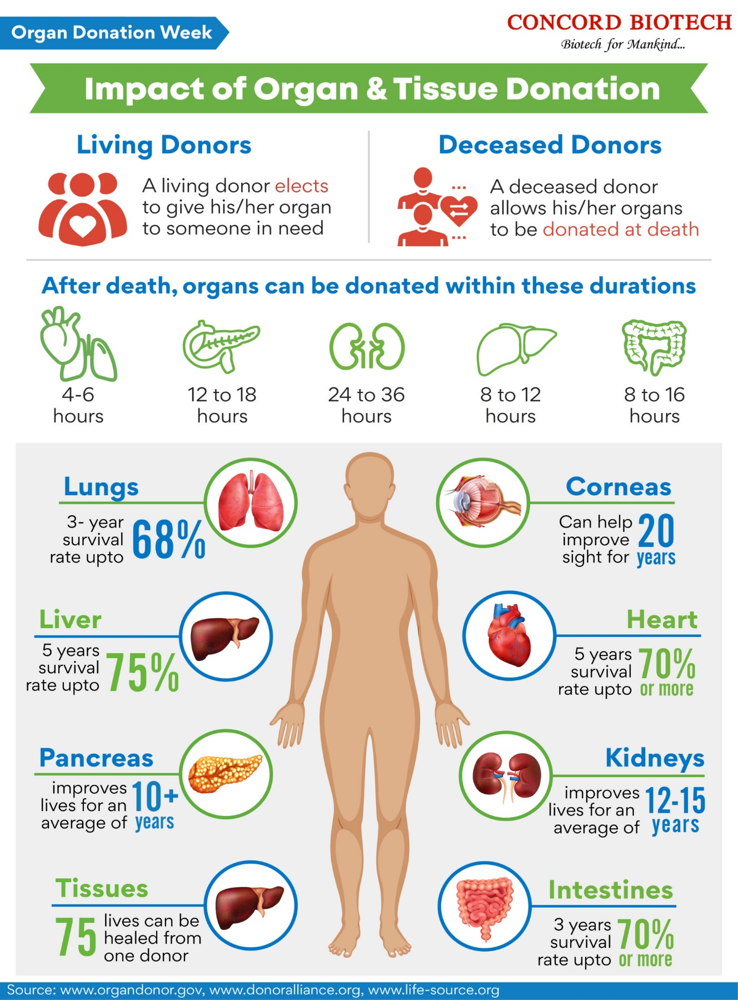

Sources include Donate Life Virginia; Mayo Clinic; Organdonor.gov; Donoralliance.org; Life-source.org

