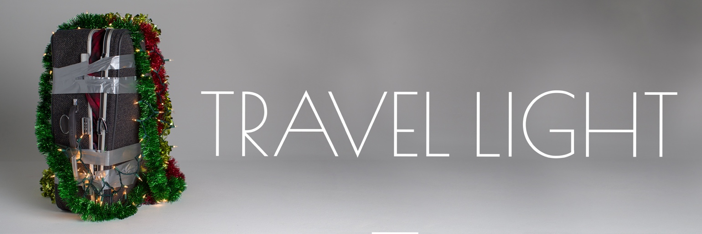

**Letting Go of Distractions**

December 6, 2020

**Proverbs 4:20-27**

**20**My son, be attentive to my words;  
    incline your ear to my sayings.  
**21**Let them not escape from your sight;  
    keep them within your heart.  
**22**For they are life to those who find them,  
    and healing to all their[[b](https://www.biblegateway.com/passage/?search=Proverbs+4&version=ESV#fen-ESV-16513b)] flesh.  
**23**Keep your heart with all vigilance,  
    for from it flow the springs of life.  
**24**Put away from you crooked speech,  
    and put devious talk far from you.  
**25**Let your eyes look directly forward,  
    and your gaze be straight before you.  
**26**Ponder[[c](https://www.biblegateway.com/passage/?search=Proverbs+4&version=ESV#fen-ESV-16517c)] the path of your feet;  
    then all your ways will be sure.  
**27**Do not swerve to the right or to the left;  
    turn your foot away from evil.

**Attentiveness .**

v. 22

John 6:63; John 14:6

**Attentiveness .**

v. 23

Hebrews 12:1

**Attentiveness requires .**

v. 27

1. **Direct your .**

Ephesians 5:15-16

Tell me what is it you plan to do,

With your one wild and precious life?

(Mary Oliver in *Summer Day*)

1. **Direct your .**

Luke 10

**Your markers can become .**

Idols will .

Idols will .

**Reflection Questions**

Using the eleven identity markers, describe yourself. Which of your identity markers do you most often consciously think about to define yourself?

How are you most tempted to allow one of your identity markers to have ultimacy?

Can you think of a time when your identity markers became idols? How did your idols fail you or degrade you?