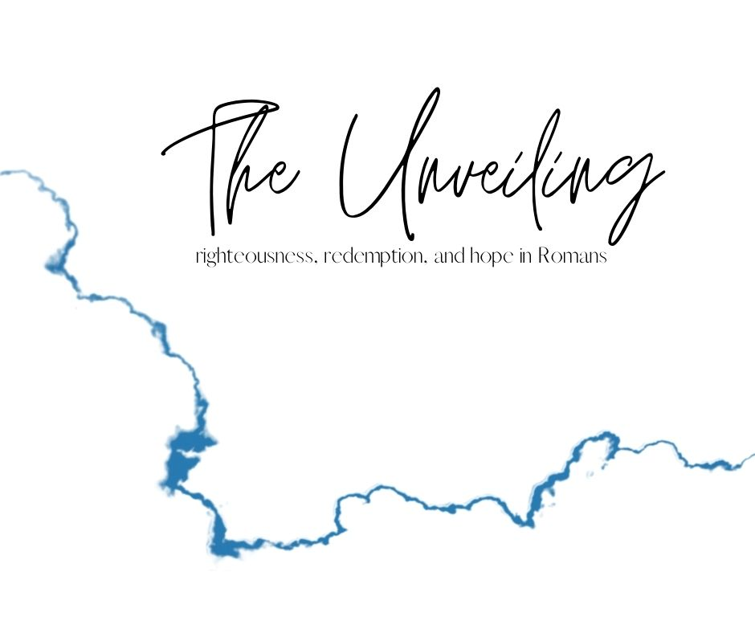

**False Reliance**

January 31, 2021

**Romans 2:12-29 (ESV)**

**12**For all who have sinned without the law will also perish without the law, and all who have sinned under the law will be judged by the law. **13**For it is not the hearers of the law who are righteous before God, but the doers of the law who will be justified. **14**For when Gentiles, who do not have the law, by nature do what the law requires, they are a law to themselves, even though they do not have the law. **15**They show that the work of the law is written on their hearts, while their conscience also bears witness, and their conflicting thoughts accuse or even excuse them **16**on that day when, according to my gospel, God judges the secrets of men by Christ Jesus.

**17**But if you call yourself a Jew and rely on the law and boast in God **18**and know his will and approve what is excellent, because you are instructed from the law; **19**and if you are sure that you yourself are a guide to the blind, a light to those who are in darkness, **20**an instructor of the foolish, a teacher of children, having in the law the embodiment of knowledge and truth— **21**you then who teach others, do you not teach yourself? While you preach against stealing, do you steal? **22**You who say that one must not commit adultery, do you commit adultery? You who abhor idols, do you rob temples? **23**You who boast in the law dishonor God by breaking the law. **24**For, as it is written, “The name of God is blasphemed among the Gentiles because of you.”

**25**For circumcision indeed is of value if you obey the law, but if you break the law, your circumcision becomes uncircumcision. **26**So, if a man who is uncircumcised keeps the precepts of the law, will not his uncircumcision be regarded as circumcision? **27**Then he who is physically uncircumcised but keeps the law will condemn you who have the written code and circumcision but break the law. **28**For no one is a Jew who is merely one outwardly, nor is circumcision outward and physical. **29**But a Jew is one inwardly, and circumcision is a matter of the heart, by the Spirit, not by the letter. His praise is not from man but from God.

.

**MESSAGE NOTES**

**A False Sense of Reliance**

**You can’t rely on the Law.**

vv. 12-24

Israel’s “one job” – a light to the nations (Isaiah 42:6)

See also Genesis 12:2-3; Exodus 19:4-6

**You can’t rely on circumcision.**

vv. 25-29

A sign of the covenant (Genesis 9:9-14)

Don’t miss Ezekiel 36:26-27!

v.29: …circumcision is a matter of the heart, by the Spirit, not by the letter. His praise is not from man but from God.

**And so…?**

**Are you relying on your LEARNING?**

**Are you relying on your LABELS?**

2 Corinthians 12:9-10

**9**But he said to me, “My grace is sufficient for you, for my power is made perfect in weakness.” Therefore I will boast all the more gladly of my weaknesses, so that the power of Christ may rest upon me. **10**For the sake of Christ, then, I am content with weaknesses, insults, hardships, persecutions, and calamities. For when I am weak, then I am strong.

* Embrace your weakness.
* Completely surrender yourself.

**GOING DEEPER**

We want to encourage you to invest more time into the book of Romans. Like we said, we won’t be looking at EVERYTHING in Romans but we will be looking at ENOUGH. Here are some ways for you to go deeper into Romans:

**Pray about what you learned today.**

If God spoke to you today, find a quite space and take the time to respond to God in prayer.

**Huddle up with some friends.**

Join with one of our Home Groups that is going through Romans. Email [micah@thecrosspointchurch.ca](mailto:micah@thecrosspointchurch.ca) to learn how to join a group.

**Do a deeper Bible Study.**

You can access our Home Group study for the week at thecrosspointchurch.ca/notes. Do the “Deeper in the Word” session for yourself.

**Read through the entire book of Romans.**

In fact, we encourage you to do it a few times, in different translations. Not sure what translations to use? Try the NIV, ESV, NLT, NASB, and The Message. If you need more translations of the Bible you can access them [here](https://www.biblegateway.com/passage/?search=Romans+1&version=ESV).

**Watch the Bible Project's "Romans" video on YouTube.**

Check out the first of two videos [here](https://youtu.be/ej_6dVdJSIU).

**Read "Paul for Everyone: Romans, Part One" by N.T. Wright as you go through the series.**

You can order a copy [here](https://www.amazon.ca/Paul-Everyone-Romans-Pt-1/dp/0664227996/ref=sr_1_1?dchild=1&keywords=paul+for+everyone%3A+romans+part+one&qid=1610250858&sr=8-1).

**Take the free Biblical Training online course with biblical scholar Douglas Moo.**

Sign up for the course [here](https://www.biblicaltraining.org/romans/douglas_moo).

**Read and pray through Romans in 31 days.**

These don't need to be consecutive days! You can find a helpful guide [here](https://www.crosswalk.com/faith/prayer/an-easy-and-powerful-31-day-plan-to-pray-through-romans.html).