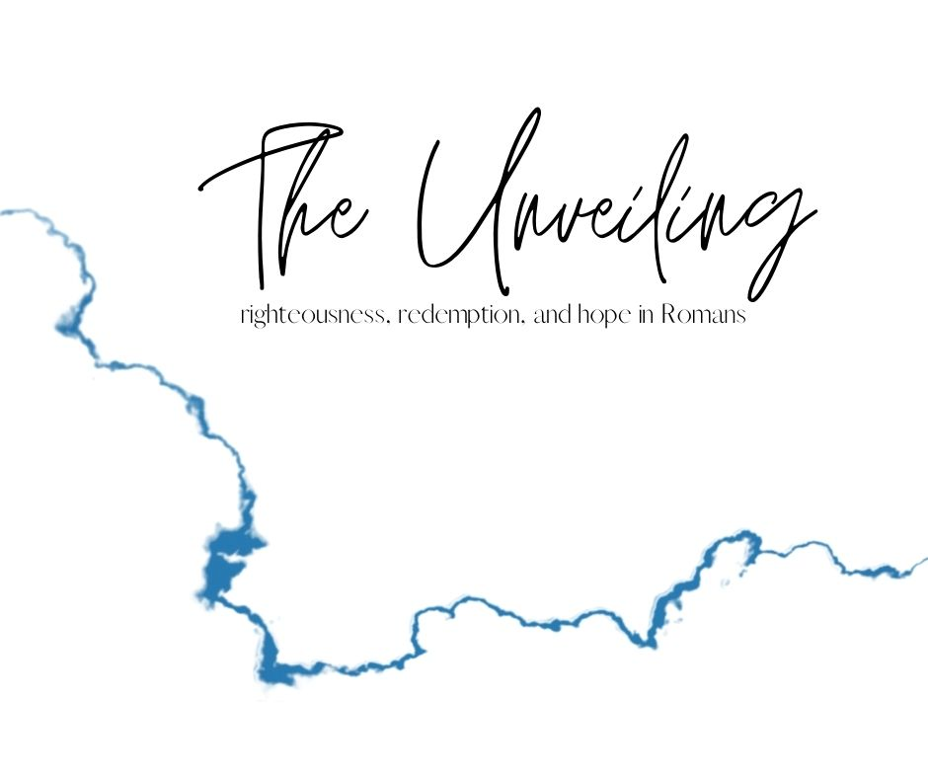

**Faith That Counts**

February 28, 2021

**Romans 4:1-12 (ESV)**

What then shall we say was gained by Abraham, our forefather according to the flesh? **2**For if Abraham was justified by works, he has something to boast about, but not before God. **3**For what does the Scripture say? “Abraham believed God, and it was counted to him as righteousness.” **4**Now to the one who works, his wages are not counted as a gift but as his due. **5**And to the one who does not work but believes in him who justifies the ungodly, his faith is counted as righteousness, **6**just as David also speaks of the blessing of the one to whom God counts righteousness apart from works:

**7**“Blessed are those whose lawless deeds are forgiven,  
    and whose sins are covered;  
**8**blessed is the man against whom the Lord will not count his sin.”

**9**Is this blessing then only for the circumcised, or also for the uncircumcised? For we say that faith was counted to Abraham as righteousness. **10**How then was it counted to him? Was it before or after he had been circumcised? It was not after, but before he was circumcised. **11**He received the sign of circumcision as a seal of the righteousness that he had by faith while he was still uncircumcised. The purpose was to make him the father of all who believe without being circumcised, so that righteousness would be counted to them as well, **12**and to make him the father of the circumcised who are not merely circumcised but who also walk in the footsteps of the faith that our father Abraham had before he was circumcised.

**MESSAGE NOTES**

FAITH counts for EVERYTHING and WORKS count for NOTHING.

**Faith counts for righteousness.**

vv. 1-5

Are we justified by faith or by works?

Justified = to be in right standing before God (righteousness)

Abraham:

Genesis 12 – The Lord first appears to him and promises him

Genesis 15 – The Lord renews his promise

Romans 4:3 is Genesis 15:6

A pagan, idolator, and sinner

vv. 6-8

David and Psalm 32:1-5

You can go on being BURDENED or you can step into BLESSING

**Faith counts for everyone.**

vv. 9-11

Abraham justified BEFORE he was circumcised.

Genesis 15 – he believed God and it counted as righteousness (age 75)

Genesis 17 – he received the sign of circumcision (age 99)

The sign of circumcision a seal of righteousness

Seal – was used to validate the authority of a claim

Abraham the father of ALL who believe.

**And so…**

**Jesus PLUS SOMETHING equals NOTHING.**

**Jesus PLUS NOTHING equals EVERYTHING.**

**GOING DEEPER**

We want to encourage you to invest more time into the book of Romans. Like we said, we won’t be looking at EVERYTHING in Romans but we will be looking at ENOUGH. Here are some ways for you to go deeper into Romans:

**Pray about what you learned today.**

If God spoke to you today, find a quite space and take the time to respond to God in prayer.

**Huddle up with some friends.**

Join with one of our Home Groups that is going through Romans. Email [micah@thecrosspointchurch.ca](mailto:micah@thecrosspointchurch.ca) to learn how to join a group.

**Do a deeper Bible Study.**

You can access our Home Group study for the week at thecrosspointchurch.ca/notes. Do the “Deeper in the Word” session for yourself.

**Read through the entire book of Romans.**

In fact, we encourage you to do it a few times, in different translations. Not sure what translations to use? Try the NIV, ESV, NLT, NASB, and The Message. If you need more translations of the Bible you can access them [here](https://www.biblegateway.com/passage/?search=Romans+1&version=ESV).

**Watch the Bible Project's "Romans" video on YouTube.**

Check out the first of two videos [here](https://youtu.be/ej_6dVdJSIU).

**Read "Paul for Everyone: Romans, Part One" by N.T. Wright as you go through the series.**

You can order a copy [here](https://www.amazon.ca/Paul-Everyone-Romans-Pt-1/dp/0664227996/ref=sr_1_1?dchild=1&keywords=paul+for+everyone%3A+romans+part+one&qid=1610250858&sr=8-1).

**Take the free Biblical Training online course with biblical scholar Douglas Moo.**

Sign up for the course [here](https://www.biblicaltraining.org/romans/douglas_moo).

**Read and pray through Romans in 31 days.**

These don't need to be consecutive days! You can find a helpful guide [here](https://www.crosswalk.com/faith/prayer/an-easy-and-powerful-31-day-plan-to-pray-through-romans.html).