**Got Questions?** There’s Q&A after the message: 587-415-1554

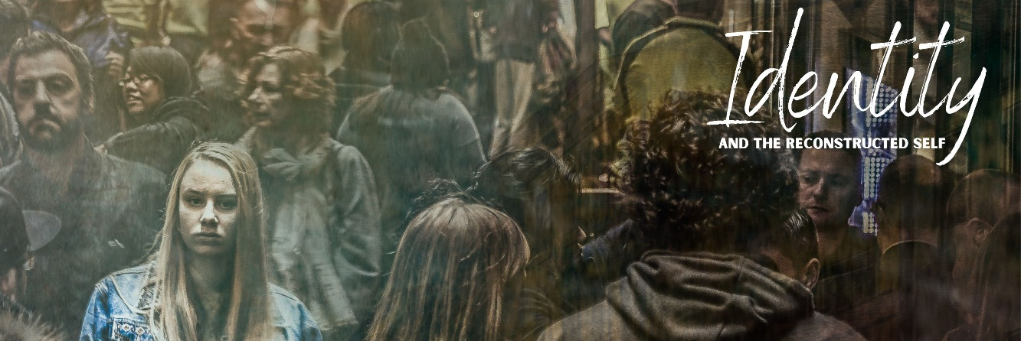

**The RENEWED SELF**

November 1, 2020

**GALATIANS 3:23-29**

23 Now before faith came, we were held captive under the law, imprisoned until the coming faith would be revealed. 24 So then, the law was our guardian until Christ came, in order that we might be justified by faith. 25 But now that faith has come, we are no longer under a guardian, 26 for in Christ Jesus you are all sons of God, through faith. 27 For as many of you as were baptized into Christ have put on Christ. 28 There is neither Jew nor Greek, there is neither slave nor free, there is no male and female, for you are all one in Christ Jesus. 29 And if you are Christ's, then you are Abraham's offspring, heirs according to promise.

**You have a .**

Eleven Identity Markers:

**You have a in Christ.**

“you are all sons of God, through faith”

“baptized into Christ…put on Christ”

**Your Christ-Identity has .**

v. 28

The Bible confirms the legitimacy of identity markers but denies their ultimacy.

**Your markers can become .**

Idols will .

Idols will .

**Reflection Questions**

Using the eleven identity markers, describe yourself. Which of your identity markers do you most often consciously think about to define yourself?

How are you most tempted to allow one of your identity markers to have ultimacy?

Can you think of a time when your identity markers became idols? How did your idols fail you or degrade you?