**Got Questions?** There’s Q&A after the message: 587-415-1554

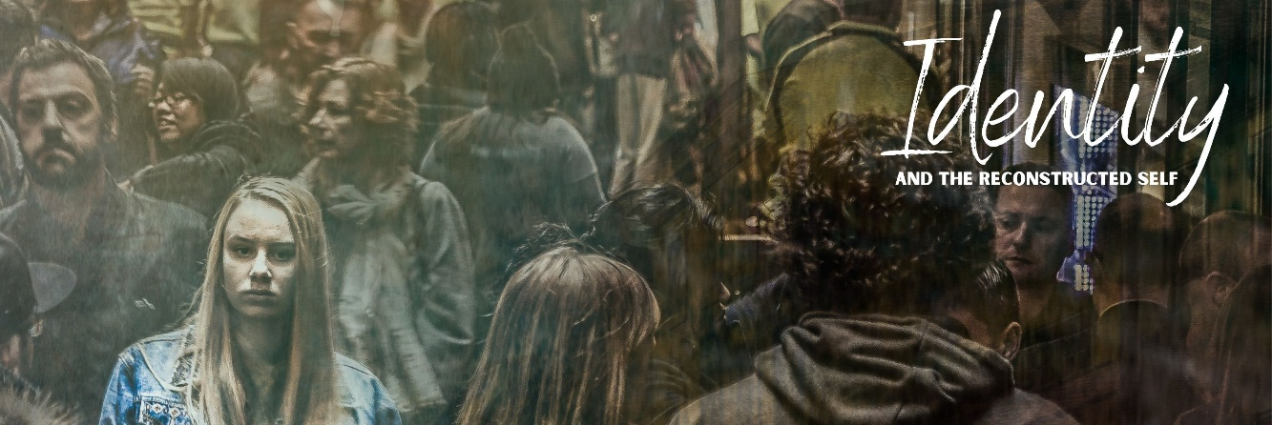

**The VERTICAL SELF**

October 25, 2020

1. **What is personal identity?**
2. **Why is your identity important?**

We are meaning SEEKERS and meaning MAKERS.

**EXPRESSIVE INDIVIDUALISM**

The way to reach the highest good is through self-expression and self-definition

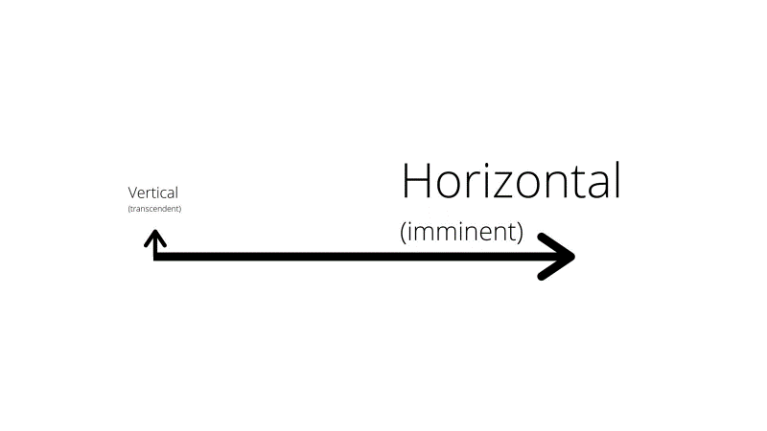

**The Cause: The Loss of the Vertical Self**

Vertical:

Horizontal:

**How did we lose the ‘Vertical Self’?**

1. SECULARISM

Religious belief is one option among many and it’s contestable (and contested)

1. THE POSTMODERN MOOD:

PM1: Deconstruction:

Religious belief is one option among many and it’s contestable (and contested)

PM2: Metanarratives Are Incredulous:

Religious belief is one option among many and it’s contestable (and contested)

PM3: Power is Knowledge:

Religious belief is one option among many and it’s contestable (and contested)

**Reconstructing the Vertical Self**

**Genesis 1:26-28**

26Then God said, “Let us make man in our image, after our likeness. And let them have dominion over the fish of the sea and over the birds of the heavens and over the livestock and over all the earth and over every creeping thing that creeps on the earth.”

27So God created man in his own image,  
    in the image of God he created him;  
    male and female he created them.

28And God blessed them. And God said to them, “Be fruitful and multiply and fill the earth and subdue it, and have dominion over the fish of the sea and over the birds of the heavens and over every living thing that moves on the earth.”

1. **People are .**

Genesis 2:7-8

1. **People are .**
2. **People are .**

Genesis 2:18

1. **People are .**

Genesis 1:27; 2:22-25

1. **People are .**

We were made for relationship with God.

We were made to point to God.

We were made to represent God.

**Psalm 139:13-14**

13 For you formed my inward parts;

you knitted me together in my mother's womb.

14 I praise you, for I am fearfully and wonderfully made

Wonderful are your works;

my soul knows it very well.

**Reflection Questions**

How have you seen expressive individualism played out in your own life?

Would you say your identity is linked more to your vertical self or horizontal self?

Which of the five factors of human identity did you need to be reminded of today?