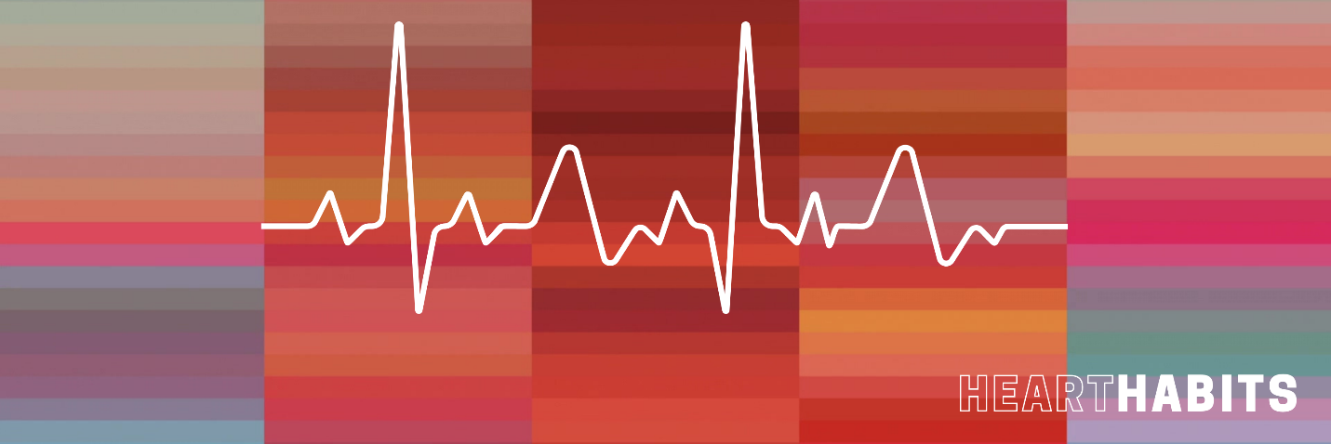**REST**

March 13, 2022

**What is Sabbath rest?**

**Mark 2:23-28**

**23**One Sabbath he was going through the grainfields, and as they made their way, his disciples began to pluck heads of grain. **24**And the Pharisees were saying to him, “Look, why are they doing what is not lawful on the Sabbath?”

A requirement of Israel: Exodus 30:8-11

A sign (seal) of the covenant: Exodus 31:16-17

Sabbath (shabbat) = “to stop”

**25**And he said to them, “Have you never read what David did, when he was in need and was hungry, he and those who were with him: **26**how he entered the house of God, in the time of[[d](https://www.biblegateway.com/passage/?search=Mark+2&version=ESV#fen-ESV-24283d)] Abiathar the high priest, and ate the bread of the Presence, which it is not lawful for any but the priests to eat, and also gave it to those who were with him?” **27**And he said to them, “The Sabbath was made for man, not man for the Sabbath.

Letter of the law or spirit of the law?

A day of blessing: Genesis 2:3

A day of refreshment: Exodus 23:12

**28**So the Son of Man is lord even of the Sabbath.”

“son of man” = human being AND a nod to Daniel 7

**Is Sabbath rest for me?**

* We are free from the requirement of observing special religious days under the New Covenant.

Romans 14:5-6; Colossians 2:16-17; Galatians 4:9-10

* The early church replaced Saturday with Sunday (resurrection day) as the day of worship.

See 1 Corinthians16:2; Acts 20:7; Revelation 1:10

1. **You were made for rest.**
2. **Find rest, or rest will find you.**
3. **To find rest, you need a plan for rest.**

How to have a good Sabbath…

* Take time to STOP.
* Take time to REFRESH.
* Take time to CONNECT. (Psalm 46:10)
* Take time to BE VULNERABLE. (Psalm 121:3-4)