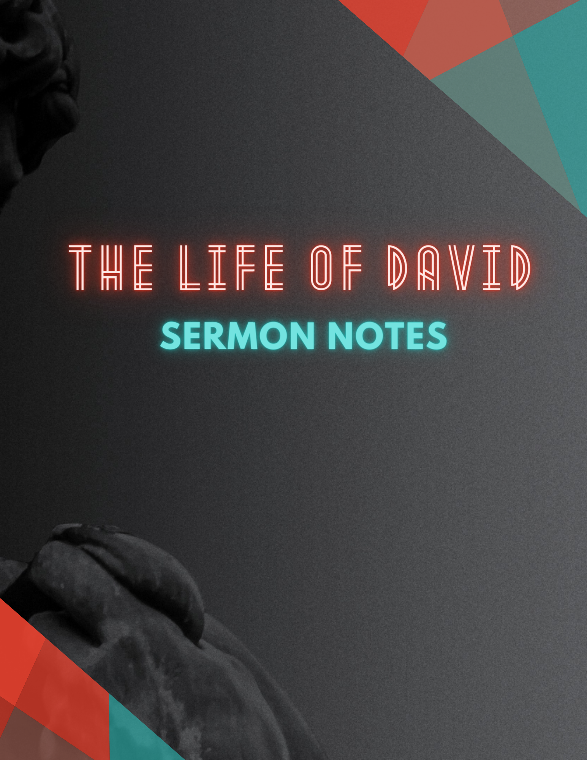

**1 Samuel 20:1-23 ESV**

1 Then David fled from Naioth in Ramah and came and said before Jonathan, “What have I done? What is my guilt? And what is my sin before your father, that he seeks my life?” 2 And he said to him, “Far from it! You shall not die. Behold, my father does nothing either great or small without disclosing it to me. And why should my father hide this from me? It is not so.” 3 But David vowed again, saying, “Your father knows well that I have found favor in your eyes, and he thinks, ‘Do not let Jonathan know this, lest he be grieved.’ But truly, as the Lord lives and as your soul lives, there is but a step between me and death.” 4 Then Jonathan said to David, “Whatever you say, I will do for you.” 5 David said to Jonathan, “Behold, tomorrow is the new moon, and I should not fail to sit at table with the king. But let me go, that I may hide myself in the field till the third day at evening. 6 If your father misses me at all, then say, ‘David earnestly asked leave of me to run to Bethlehem his city, for there is a yearly sacrifice there for all the clan.’ 7 If he says, ‘Good!’ it will be well with your servant, but if he is angry, then know that harm is determined by him. 8 Therefore deal kindly with your servant, for you have brought your servant into a covenant of the Lord with you. But if there is guilt in me, kill me yourself, for why should you bring me to your father?” 9 And Jonathan said, “Far be it from you! If I knew that it was determined by my father that harm should come to you, would I not tell you?” 10 Then David said to Jonathan, “Who will tell me if your father answers you roughly?” 11 And Jonathan said to David, “Come, let us go out into the field.” So they both went out into the field.

12 And Jonathan said to David, “The Lord, the God of Israel, be witness! When I have sounded out my father, about this time tomorrow, or the third day, behold, if he is well disposed toward David, shall I not then send and disclose it to you? 13 But should it please my father to do you harm, the Lord do so to Jonathan and more also if I do not disclose it to you and send you away, that you may go in safety. May the Lord be with you, as he has been with my father. 14 If I am still alive, show me the steadfast love of the Lord, that I may not die; 15 and do not cut off your steadfast love from my house forever, when the Lord cuts off every one of the enemies of David from the face of the earth.” 16 And Jonathan made a covenant with the house of David, saying, “May the Lord take vengeance on David's enemies.” 17 And Jonathan made David swear again by his love for him, for he loved him as he loved his own soul.

18 Then Jonathan said to him, “Tomorrow is the new moon, and you will be missed, because your seat will be empty. 19 On the third day go down quickly to the place where you hid yourself when the matter was in hand, and remain beside the stone heap. 20 And I will shoot three arrows to the side of it, as though I shot at a mark. 21 And behold, I will send the boy, saying, ‘Go, find the arrows.’ If I say to the boy, ‘Look, the arrows are on this side of you, take them,’ then you are to come, for, as the Lord lives, it is safe for you and there is no danger. 22 But if I say to the youth, ‘Look, the arrows are beyond you,’ then go, for the Lord has sent you away. 23 And as for the matter of which you and I have spoken, behold, the Lord is between you and me forever.”

_______________________________________________________________________________

**Relationship Assessment:**

Are they safe?

What do you have in common?

Are they trustworthy?

Can you both be vulnerable?